Ching Hey Lau

chinghey.lau@newhallstudent.co.uk/ hheylau@gmail.com

Investigating project

Computer science NEA 2022-2023

Unity 3D Maze Runner Game

Content Page

1. Analysis 5

1.1 Introduction 5

1.1.1 Background 5

1.1.2 Project Scope 5

1.1.4 Target audience 6

1.2 Investigating Project 6

1.2.1.2 Questionnaire and Statistics 6

1.2.1.4 Existing Software 14

1.2.1.5 Prototyping 20

1.2.10 Analysis Data Dictionary 21

1.2.11 Data File Size /Volume 22

1.3 Specific Objective 22

1.3.1 Splash Screen 22

1.3.2 Main Menu 22

1.3.3 Setting Screen 22

1.3.4 Quit Panel 23

1.3.5 LeaderBoard 23

1.3.6 Login & Register 23

1.3.7 Start Game Save Slot Selection Panel 24

1.3.8 First Time 24

1.3.9 Character Selection 24

1.3.10 Maze Generation 24

1.3.11 Loading Screen 24

1.3.12 Main Game 24

1.3.13 Weapon 25

1.3.14 Monster 25

1.3.15 Maze 25

1.3.16 Exit 25

1.3.17 Health 25

1.3.18 Pause Menu 26

1.3.19 Game Over 26

1.4 Additional Objectives 26

1.4.1 Path Finding 26

1.4.2 Visual Improvement 26

1.4.3 Monster 26

1.4.4 Special Feature 26

1.4.5 Quest System 26

1.4.6 Achievement System 26

1.4.7 Inventory 26

1.4.8 Pick Up 27

1.4.9 Music 27

1.4.10 Rewards 27

1.4.11 Online Service 27

1.4.12 Multiplayer 27

1.4.13 Ghost System 27

1.4.14 Wooden box 27

1.4.15 Vending Machine 27

1.4.16 Terrain 27

1.4.17 Action Replay 27

1.4.18 Player Profile 27

1.4.19 Database 28

1.5 Proposed solution 28

2. Design 28

2.1 High-level overview 28

2.1a System flowchart (whole diagram) 28

i) Login Screen and splash screen 29

ii) Main menu screen (Leaderboard, Setting, Quit and Start Game) 30

iii) Maze Game 31

iv) Game Over Screen 32

2.1c Data Flow Diagram 32

2.2 Modular in structure of system 33

2.2a Site map 33

2.2b System chart 34

2.1f Table of Class 35

2.2b Variable declaration of Main Algorithm 47

2.2c IPSO 47

2.3 Data Items & structures 48

2.4 Data Structures 49

2.5 File Structure and Organisation 49

2.6 Identification of main algorithms 49

2.6a 49

2.6b Maze Generation (DFS) 49

2.6c Stack 51

2.6d Merge Sort 51

2.6e Binary Search 52

2.6f Opening Sequence (Fisher-Yates shuffle) 52

2.6g Gravity 53

2.6i Dijkstra 53

2.6j Hashing 57

2.6k Circular Queue 58

2.6l A* 58

2.6m Time 58

2.6n hexadecimal → denary 58

2.6o Register checking 59

2.6p Fading 59

2.6q Outermost Wall and Exit Tunnel 60

2.6r Linked List 61

2.7a Online Query 63

2.7b local SQLite Query in Save0/1/2.sqlite3 65

2.1b Class diagram (UML) 69

2.8 Identification of Storage Media 71

2.9 HCI Rationale 71

2.10 HCI Sample of Planned Input Design 72

2.11 HCI planed output design 73

2.12 Hardware and Software requirement 74

2.13 Description of measures planned for security and integrity of data 74

2.13a Security of the data 74

2.13b Integrity of the data 74

2.13c Access Control 74

2.14 System security 74

2.15 Overall Test Strategy 74

3. Technical Solution 75

4. Testing 75

5. Feedback and Evaluation 79

5.1 User Feedback 79

5.1.1 Positive comment I have got is: 79

5.1.2 The negative comment: 79

5.2 Objective Feedback 80

5.2.1 Bugs that player has encountered is 80

5.3 Improvement and extension 80

5.3.1 The improvement comments that player has given is: 80

5.3.2 Improvement I could made 80

# 1. Analysis

## 1.1 Introduction

### 1.1.1 Background

Maze Runner has been a best-selling thriller movie since its release in 2014 and is based on the novel by [Noah Oppenheim](https://www.bing.com/ck/a?!&&p=1f6dfeea94717e41JmltdHM9MTY3OTM1NjgwMCZpZ3VpZD0zMWU5YmYwOC02OTMxLTZlNWItMzNhZC1hZGIzNjgzOTZmM2EmaW5zaWQ9NjIwOA&ptn=3&hsh=3&fclid=31e9bf08-6931-6e5b-33ad-adb368396f3a&u=a1L3NlYXJjaD9GT1JNPVNOQVBTVCZxPU5vYWgrT3BwZW5oZWltJmZpbHRlcnM9c2lkOiJjNDkyYTNhNi1jN2Y2LTZkYjAtZDgzMy05ZWExNzQ1ZGI5ODgi&ntb=1). In the story, a group of boys who are immune to a zombie virus are trapped inside a mysterious maze for scientific investigation. Scientists have found that higher brain activity creates more immune substances, so they put in a giant and poisonous monster called Griever. They are trapped inside a moving maze with a different opening sequence every day. The story is about the main character, Thomas, who has been trying to uncover the secret of the maze and leading a team to get out of the maze.

This film is one of my favourite movies as the audience is immersed as Thomas, through him, we understand how the maze works and the relationship and mentality of the aborigines. The scene of Thomas bravely exploring and surviving inside the maze successfully makes the audience feel intensely worried about him. After the movie, I had been dreaming of myself as Thomas, dealing with the "horrible monster" and exploring and escaping the maze. Also, as a survival movie, humanity, betrayal, and trustworthiness have been emphasized, which has which makes you reflect on what it means to be a human in society.

There are lots of maze-solving games, but only a few of them are similar to the movie. I would like to make a game on top of the original storyline that would simulate Thomas, the main character, contributing to the village and communicating with and building relationships with NPCs. And once Thomas has gained enough resources, he can solve the maze, escape, and handle the zombie outside of the maze. Also, I would like to make this game as realistic as possible, as the settings and story of the game could happen, and the player needs to immerse himself in the world of The Maze Runner.

### 1.1.2 Project Scope

The genre of my game will be Role Play Game and maze solving game. As an RPG game, the player will substitute into the main character to grow and explore the maze and villages. The resource will be randomly generated in the zone like woods in the forest zone. Food can be found in the farming zone which randomly generated every 2 days. Houses with a craft table which used for building tools and trap will be in the village zone.

As an RPG game, the interaction of NPC and the plot is important to the game. Tutorial will be shown in dialog from the NPC to let the player fully understand the game mechanics. Player needs to collect resource in the zone mentioned above to craft the weapon to attack and defence the grievers. The player should allow to explore the maze when he has the basic kit of exploring. As the player collect more rare resources, they could upgrade the weapon or create different utilities such as traps.

There is similar type of maze game called labyrinth game. However, labyrinth game doesn’t aim to be explore or solve. It provides a fixed path without a dead-end. In compare to maze-game which is opposite to labyrinth leads to higher difficulties. To make the game unique, the maze is randomly generated in every new game so the player wont get bored or reciting the maze pattern and gate opening sequence.

There are 8 separate maze zone in each game and every zone include a path to reach to the outer maze between the wall pattern. The gate of the maze only opens in daytime and close at sunset. Player needs to navigate the maze to the outer maze using the help of mini-map and hints on the wall to pass through the maze. Player has to fight with the monster alone if he didn’t get back to the safe zone. The monsters will start attacking the player every few second if the monster is close to the player until the player or monster is dead or far away. Once the monster dead, rare loots or key will have a chance for player to pickup. However, if the player is dead, he would have an option to rewind to few minutes ago or respawn in the safe zone.

Monster will only spawn in night-time in the maze area. They will move slowly to the player using A* path finding algorithm and chase the player once monster has alerted and detected the player. There will be abundant of monsters but most of them are weak. Blades and a main boss griever will be spawn in the outermost maze before player can exit through the escape tunnel. Once the boss monster is dead, all monster will be destroyed and no more monster will be spawned. To escape the maze, password and enter key must be found in the maze before the maze gate can be opened.

Some of the character in my game will be based on the movie. I will add different ability to each character including speed boost and strength increase to differentiate different type of player by choosing the player’s best fit. For the texture of this game, it could have more variant such as Japanese traditional temple maze or the Beijing palace. The UI design could be using command line interface to fit into the plot of Maze Runner which everything in the maze is generated by a supercomputer.

### 1.1.4 Target audience

Based on the results collected from the Questionnaire on the 1.2.1.2, the game will target on male gamers around the age of 15 to 25 most of whom are students. The majority of the respondents do play games however their time is quite limited and they mainly play at the weekend or 1-2 days per week. Also, mobile platforms and Nintendo switch are popular platform teenagers play on and because of the easy to access in terms of hardware and time. Two main factors have influenced my decision making process for this project. Firstly, the fact that most teenagers now own a mobile phone, which are generally cheaper than a pc. Secondly, the limited time available to teenagers to play. These points have convinced me to build the game on mobile platforms. As this game is designed to be realistic, with blood effects and will include challenging puzzles, this game will not be available to children.

## 1.2 Investigating Project

### 1.2.1.2 Questionnaire and Statistics

===================Personal Detail/ client ======================

1. Gender

Male ----(5 votes) (71.43%)

Female----(2 votes) (28.57%)

1. Age Range

Under 12 ----(0 votes)

12-15 ----(0 votes)

15-17----(2 votes) (28.57%)

18-25 ----(5 votes) (71.43%)

26-35----(0 votes)

Over 35----(0 votes)

1. What is your job currently

Part-time job ----(1 votes)

Student ----(6 votes)

1. How often do you game?

I don’t play games ----(0 votes)

Weekend ----(5 votes) (71.43%)

3-5 days per week ----(0 votes)

Every day ----(2 votes) (28.57%)

Most of the respondents play on the weekend. This game should not force players to login everyday to gain special items

1. How long do you game?

0-1 hr/day ----(4 votes) (57.1%)

1-2hrs/day ----(1 votes) (14.3%)

2-3hrs/day----(2 votes) (28.57%)

more than 3 hours /day ----(0 vote)

Most of the respondents play less than 1 hour, so I will adjust the game to be fun and intense as well as taking less time to complete.

1. How often do you open a game more than once a day

Always ----(4 votes) (57.1%)

Seldom ----(3 votes) (42.9%)

Never ----(0 votes)

the game should consider having a pause and continue function so that the player can continue their last session.

1. What game platform do you prefer

Mobile ----(3 votes) (42.9%)

PC ----(5 votes) (71.4%)

XBOX or PS4 ----(2 votes) (28.6%)

Nintendo switch ----(3 votes) (42.9%)

Although PCs have the most votes, mobile platforms including mobile and Nintendo switch combined have gained a larger portion than PC player

1. What kind of game do you prefer

Role-playing Game ----(4 votes) (57.1%)

First Person Shooter ----(5 votes) (71.43%)

Third Person Shooter ----(1 votes) (14.3%)

Battle Royale ----(2 votes) (28.6%)

Arcade game ----(2 votes) (28.6%)

Sandbox (Minecraft/ Terraria) ----(5 votes) (71.43%)

Puzzle / Problem solving game----(3 votes) (42.9%)

Action-Adventure game ----(4 votes) (57.1%)

Most People like sandbox, First Person Shooter. This proves most respondents are familiar with playing 3D games and know most of the 3D game mechanics. Role-playing games and action adventure games come as second which shows the rewards and game experience is important to the player.

=========================Gameplay ========================

1. how long should one game session last?

5 -10 mins ----(1 votes) (14.3%)

10-15 mins ----(4 votes) (57.1%)

15--20 mins ----(2 votes) (28.57%)

most of the people don’t want a game to last too little time or too long. 10 -15minutes is the best time range for most of the respondents

1. In a game fighting with AI monster, what weapon would you prefer?

melee ----(1 votes) (14.3%)

Explosive----(2 votes) (28.57%)

knife ----(1 votes) (14.3%)

punch ----(0 votes)

arrow or throwable weapon-----(5 votes)(71.4%)

most of the players would like to deal some damage to the monster without getting too close to the monster. Throwable weapons will be added as a weapon option

1. What fight mode do you prefer?

defensive(trap) ----(1 votes) (14.3%)

attacking (arrow, stone, sword and maybe gun) ----(6votes) (85.7%)

most of the players would like to active attack the monster instead of defensive playing. It is because defensive is more unpredictable compared to attacking. And you gain rewards from killing monsters by player himself.

1. Which one do you prefer the frequency of monster appearing?

Weak but abundant ----(1 votes) (14.3%)

Strong but few ----(6 votes) (85.7%)

Most of the respondents prefer few monsters but will high damage or enhanced health.

1. In a game, which mode do you prefer

Endless mode ----(0 votes)

With an ending (then restart) ----(7 votes) (100%)

Most of the players want to have a game with an ending. An ending could be an emblem of the player beating the game

1. After the game end, how should the game behave?

go to next level ----(5 votes) (71.4%)

stay at current game session----(2 votes) (28.57%)

Most players want to challenge for a harder level instead of improving the current score and level before moving on. The player may have limited time so the next level will automatically loaded after the player beats the game.

1. Which attack mode do you prefer

Aim to attack ----(5 votes) (71.43%)

Distance to attack ----(2 votes) (28.57%)

most of the respondents would like to attack the monster precisely by aiming with crosshair and make the game more realistic.

1. Should NPC (AI) affect the overall gameplay? Different objective

Yes ----(6votes) (85.7%)

No ----(1 votes) (14.3%)

The NPC could prove different objective and reward after objective have met. Also, the key to opening the gate could also be gained by killing the monster.

1. should game add a loot box(chest) or bonus box

Yes----(7votes) (100%)

No ----(0 votes)

A loot box should be automatically spawn at the start of the game and loot box will spawn inside the safe zone

1. Which one do you prefer

Time limited ----(2 votes) (28.57%)

No time limit ----(5 votes) (71.43%)

Most of the respondents don’t want to have a limit on time. It may because it is have too much pressure on playing a game.

1. Which way is the best way for a player to gain money

collect resource gems ----(0 votes)

loot from the monster ----(1 votes) (14.3%)

complete the quest ----(5 votes) (71.43%)

Selling stuff and earn token----(0 votes)

By working, wood-cutting, farming ----(1 votes) (14.3%)

Most respondents has chosen completing the quest to gain money. It could combine with the objective provided by the NPC.

1. Should level system link to difficulty

Yes----(6votes) (85.7%)

No ----(1 votes) (14.3%)

most of the respondents would like to merge difficulty with level which means higher level will be more difficult.

1. should the game include weekly login/daily login bonus?

Yes ----(4 votes) (57.1%)

No ----(3 votes) (42.9%)

The game should award player who play this game every period of time by giveaway rare weapon and coins

1. Do fast travel/ player teleport affect game balance

Yes ----(5 votes) (71.43%)

No ----(2 votes) (28.57%)

Fast travel will affect the game balance according to most of the respondents so this feature will not be added into the game. Reasons may be unfair to the time used to other player.

1. when the final boss is killed, should side/minor monster be

Stay in the game for player to kill ----(3 votes) (42.9%)

Die with the boss ----(4 votes) (57.1%)

Tame-able/loyal to player ----(0 votes)

All monster should be dead when the boss (main monster) is dead.

1. When should the monster awake and chase the player?

Only daytime ----(0 vote)

Only night-time ----(2 votes) (28.57%)

Both----(5 votes) (71.43%)

s the monster can trigger loot and reward, most of the respondence are willing to fight with the monster no matter when the time of the day is.

1. Should day and night last

fast ----(4 votes) (57.1%)

slow ----(3 votes) (42.9%)

most of the respondents prefer faster paced game and it could save the time and make the game become more intense.

1. What player should award by finish objective

Token/ coin ----(1 votes) (14.3%)

Level up ----(1 votes) (14.3%)

Rare weapon ----(4 votes) (57.1%)

Power and effect (strength and invisible) ----(1 votes) (14.3%)

Most respondents chose rare weapon as an reward after finishing the objective of the game.

1. What powerup do you like to appear most oftenly

Strength -more attack ----(4 votes) (57.1%)

stealth, invisible----(4 votes) (57.1%)

Run 1.2x faster ----(4 votes) (57.1%)

Get the path of the maze ----(1 votes) (14.3%)

There is a tie with strength, stealth and speed boost power-up. Those 3 of the powerup would be randomly chosen by the system

1. For easy level

decrease monster hp (health) ----(5 votes) (71.43%)

increase damage of weapon ----(1 votes) (14.3%)

higher chance to get expensive item ----(2 votes) (28.57%)

The monster health should be decrease to match the difficulty of easy level.

1. How should level be measured

By monster kill count ----(1 votes) (14.3%)

By money earned ----(1 votes) (14.3%)

By number of objectives finished ----(3 votes) (42.9%)

by timer ----(2 votes) (28.57%)

Most respondents agree to have the more objective finished, the higher level you could earned.

1. Earn money by

timer ----(0 votes)

killing count ----(7votes) (100%)

Most respondents would like to gain money by player killing monster.

1. which one do you prefer

multi tab setting menu----(5 votes) (71.43%)

scrollable setting menu ----(2 votes) (28.57%)

Multi-tab setting menu would be used in the setting menu of my game

1. should monster start attack you in sight

Yes ----(6votes) (85.7%)

No ----(1 votes) (14.3%)

The monster will attack player only when monster have seen player

1. would you rather have a default weapon or random weapon provided?

Default weapon (strong) ----(3 votes) (42.9%)

random weapon (sniper, shotgun, AK 47) ----(4 votes) (57.1%)

Most respondents would like to have different choice and properties of weapon

1. In the game, which chasing method of monster you prefer?

moving to you slowly constantly ----(5 votes) (71.43%)

moving fast but stop in a while ----(2 votes) (28.57%)

The speed of the monster should be slower than the walking speed of the player to give enough space for player to attack and escape

1. Which kind of currency do you prefer

counting in dollars ----(6votes) (85.7%)

counting in 100 ----(1 votes) (14.3%)

Most respondents prefer a actual amount of imaginary large number of money in game

1. where do you want to path appear?

On the mini-map ----(6votes) (85.7%)

visible on the floor ----(1 votes) (14.3%)

There should be a path visible in the mini-map inside the game

1. Should weather affect the movement?

(Rainy day walk slow, sunny day speed boost)

Yes----(4 votes) (57.1%)

No ----(3 votes) (42.9%)

The weather system should be added into the game which special effect due to the weather

1. If player die, should the player

Be punish in some way (health bar decrease or some coin lost) ----(4 votes) (57.1%)

act like nothing but death count + 1 ----(3 votes) (42.9%)

Over half of the respondents would like to have a punishment when the player is dead

1. If the player respawn, should player spawn in

the safe zone (far from exit) ----(7 votes) (100%)

where player dead (maybe unsafe or near to another trap) ----(0 vote)

Most respondents would like to respawn into the safe zone no matter they have to reexplore the map again

1. Which aim do you prefer?

Kill 20 monster ----(4 votes) (57.1%)

Explore 3 zone ----(4 votes) (57.1%)

Survive a cruse night attack ----(4 votes) (57.1%)

collect 30 coins ----(1 votes) (14.3%)

Find a secret tunnel ----(4 votes) (57.1%)

Objective that respondents would like to have is killing certain amount of monster or a wave of monster, exploring the map and the secret tunnel.

1. Which perspective you would like a 3D Maze Runner to be?

First Person ----(1 votes) (14.3%)

Third Person ----(1 votes) (14.3%)

Both (switchable) ----(5 votes) (71.43%)

Most respondents would like to have a choice changing between first and 3rd person perspectives

1. Do you like lobby music (background music)

Yes ----(5 votes) (71.43%)

No----(1 votes) (14.3%)

Sometimes ----(1 votes) (14.3%)

Most of the respondents would like to have music playing in the background while in main menu and game lobby

1. Should the speed/ strength of different character be different?

Should be different ----(6 votes) (85.7%)

Should be the same ----(1 votes) (14.3%)

Most respondents would like to see more variant available in the game including characters and their own different abilities

1. What is the best way to heal/ recover health?

Buy food from the shop (spend money) ----(6 votes) (38%)

Free limited supply of medicine each round----(4 votes) (24%)

Collect heart from the ground----(2 votes) (13%)

Kill monster and have a chance to heal----(4 votes) (24%)

Most respondents prefer spending money to buy medicine to recover the health.

1. Which power-up would you prefer

speed increase ----(5 votes) (71.43%)

destroy monster near player (in range) ----(2 votes) (28.6%)

Slowness ----(1 votes) (14.3%)

Strength ----(6votes) (85.7%)

Instant health increase ----(5 votes) (71.43%)

Resistance to attack ----(4 votes) (57.1%)

Invisible/ Invincible to monster ----(4 votes) (57.1%)

Most of the respondents prefer having strength power-up which deals more damage to the monster.

=================Comment on my game ============================

1. Have your ever watch maze runner （移動迷宮）？

Yes ----(4 votes) (57.1%)

No ----(3 votes) (42.9%)

the next 2 question will be based on the answer from question 46

Most of the respondents have watched maze runner.

1. Do you like that film?

Yes ----(4 votes) (57.1%)

No ----(3 votes) (42.9%)

All of the 4 respondents who watched the movie like the film. This proves the high selling box office of the maze runner has gained exposure and reputation could made this game become popular and easy understand plot.

1. What feature of the movie would you prefer to add into the game?

(The monster? the WCKD laboratory? the farming in safe zone?)

-WCKD laboratory

-The farming area in safe zone

-Storyline from the movie

The zone could contain farming section. WCKD laboratory and the storyline from the movie could be added and adjusted to make the game similar to the movie

========================Feature ==============================

1. what additional feature I didn't mention above is suitable for maze game?

(This would help a lot and better to my game)

-resistance to monster attack

-a rare chance for player to fly on the sky for few second so that the player can know the maze structure a bit

-earn new characters

-rare item loot chest in secret tunnel

The character could be bond with the award system. Power-up like invincible and maze reveal can be added to the game. Rare item can be placed in secret tunnel to award player

1. Why do you play game? What aspect of game you enjoy the most?

-Kill

-relax (2 votes)

-Getting progress e.g., level up, being stronger

enjoy teamwork or play alone

-Maze is fun

-Happiness of passing a level

Main Conclusion: A game session should last around 10-15 minutes with a story with ending. Most of the respondent would like gain an achievement of finishing the game and wants to play game relaxed. Time limit and fast travel will not be added to the game as it might affect the game balance. Objective should be easy to achievable and the hard one could be defined as an achievement of player. The player will award for playing my game regularly but not daily.

Coins and rare weapon should award after monster has been killed by the player or quest has been done. The level should be able choose by player and it refer to the difficulties of maze and the strength of the monster attack. The current of the game is count in small amount and player could use the coins in vending machine for trap and grenade to deal damage to the monster. This could provide a creative way to play this game.

Mini-map will be shown on the main game. Monster, player location and the maze structure will show on the mini-map. To match with the movie, the player should transfer from the laboratory to the maze and farming zone in the safe area. As mobile phone is easy to carry and the requirement to acquire a mobile device is fairly low, it is an ideal platform for my game. However, criteria of touch friendly should be aware when designing the User Interface.

### 1.2.1.4 Existing Software

Game 1: Escape the glade

This game is described as inspired by movie “maze runner”. The texture is similar to the movie and the storyline is pretty much the same

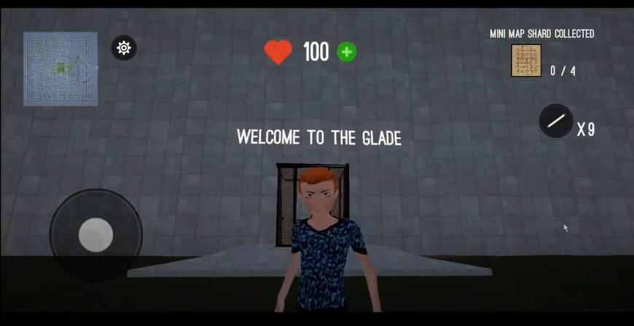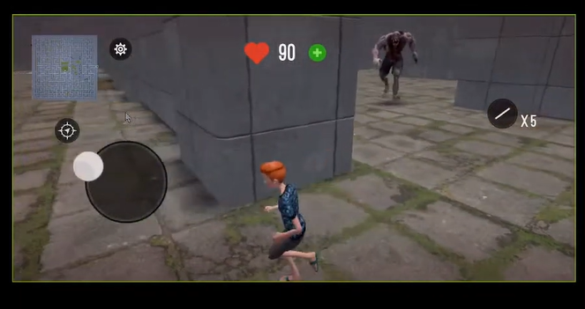

Pros:

* The sky and the wall texture are good and clear to see and identify
* There is different texture between grass and wall and similar to the movie maze runner
* It has a simplified mini-map and real time locate player location
* A lift is transported at the start and the end of the game which pay tribute to the movie
* A light bar that allows you drop on the floor for bookmarking the direction of player
* Graphics setting is included to make the game compatible with less powerful phones
* The lobby music is energetic
* Power-up and health boosts available by watching ads
* The player and monster animation is fully animated and runs smoothly

Cons:

* There is no way to take the monster down (no trap and attack method)
* The map is too complex, you can’t win this game without screenshot and the map planned beforehand
* In this game it is easy to get lost but the monster keeps chasing you
* No achievement after you successfully escape
* The lobby music is repeated and becomes annoying at a few time.
* You can go back to the laboratory as the lift doesn’t disappear after the start
* The blood effect affects the camera vision and it never disappears
* Mini map should update even though it is closed
* The monster keeps following the player wherever the player is (even though the player is not in sight of the monster)
* There is no safe place or cooling down for monster chasing
* The map is not randomly generated (same map every time)

Conclusion: Unlike the movie, the maze is fixed and only one objective. It is quite boring whilst the monster is too overpowering. This game uses unreal engine, this explains why the graphics and texture is rendered to perfectly match. The map should be more straight-forward and without any external tools for players easier to solve. My suggestion is to add a navigator and the ability to draw and highlighted in the minimap. The monster chasing is very annoying as I can’t pause and play the game in a relaxed way. I would add a combat system to allow players to kill and defend from the monster. For example, powerful weapons and armour protection and to be able to setup some trap like a speaker making some noise to attract the monster and confuse them. The monster that is killed by the player could drop some loot and clue. I would add some more NPC to assist the player and some more variants of monster. Furthermore, the ability to locate the monster in the minimap could help the player to aFunction them. The blood recovery system and navigation system are connected to ads however the ad service is not working which is disappointing as the blood can’t recover and it affects the gameplay. I would suggest having some methods of healing yourself. Moreover, as the map pattern is fixed and complex to solve, player need to screenshot and plan the route before solving the maze. It is nearly impossible to solve it at one go or without planning. Blood effects should be minimal because it keeps showing on-screen affecting the whole gameplay.

Game 2: RPG-Maze

This game has a random map generator which is a bonus and delighted me a lot. This game uses a stereogram texture. The camera is free to move too.

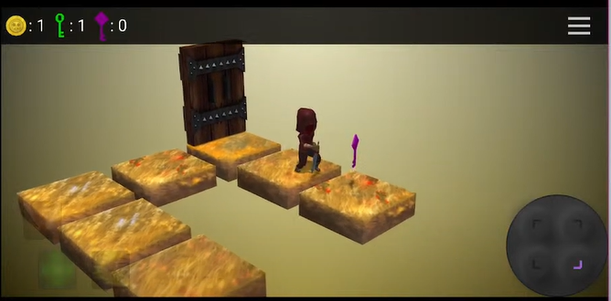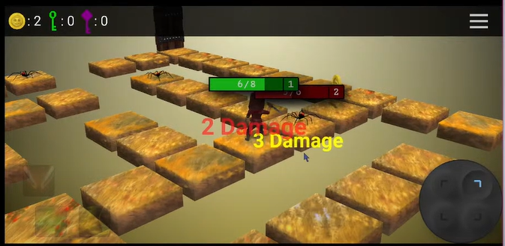

Cons:

* The input is hard to input and control as it is 4 separate buttons and it is fixed at the corner which hard to reach
* Walking speed/ animation is too slow (better if timescale could double or Fast-Forward
* This game has no jump option which wasted a lot of time going to a sim
* The damage of fighting is too random and unpredictable
* The high pitch lobby music keeps looping and makes me feel annoyed

Pros:

* Good UI – including joystick, health bar and health change text
* Predictable monster movement
* Player can deal one more damage to the monster as the monster attack is delayed
* The loading screen is fancy and separate from the main game
* There is achievement and reward after finishing each level
* The movement of the character walking is fully animated
* Background music is included in the game
* The setting has an option to turn off the music
* The map is randomly generated even though it is in the same level
* Token and Power-up system [fire/ sprint/ heal system]
* Level preview function (provide a detail of number of monster and keys)

Conclusion: The objective of this game is quite clear. They are all located at the top with an icon. The tutorial is clear for players and players could easily understand and follow. The collection of the key is also the main objective of my game as it is used for opening the maze so I could use it as a reference. However, pattern of the key generation in this game is usually located at the furthest corner which means the player needs to takes a lot more time to finish a simple task. Also, the character moves quite slowly, I would consider adding a speed up option for player. Although this game has the advantage of a delayed monster attack, it also has an unfair combat system because the damage is unpredictable which means it is a risk to challenge the monster in this game.

Game 3: Endless Maze Runner Survival 2

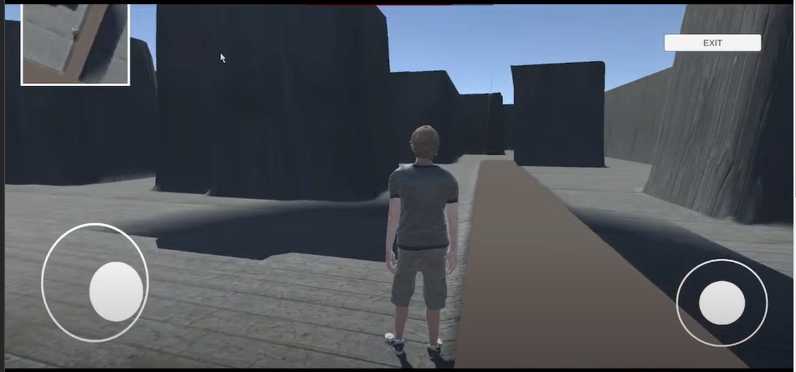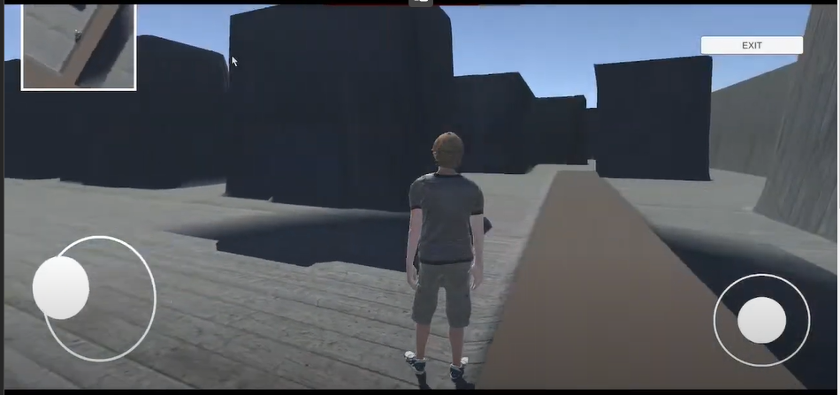

Pro:

* The game is playable and joystick control is quite good
* The movement and turning could be a reference to my game
* The minimap to show where the player is located

Cons:

* The texture is too simple/ not attractive
* This game has no interactive element, NPC nor monster.
* There are only 1 level in the game.
* It is impossible to find the exit as there are not any hints on the mini map or the game
* This game has no other objective and it is easy to get lost
* The camera can look through the wall in third person perspective
* There are too many ads in the game. When ads appear at start and end of the game
* There is no day-night shift and the shadow of the wall is unrealistic as some of them are floating in the mid-air
* The position of the joystick cannot be adjusted which is not user-friendly
* The speed of the character is too slow. It takes more than 15 seconds to walk to the finish line in a short distance

Conclusion: The game engine, the setting and the map of this game is similar to my prototype. However, this game is barely playable. The mini-map in this game could be improved as it is currently completely useless to solve the maze. But this game has quite natural and responsive animation while the character is moving.

Game 4- Maze RPG Dungeon

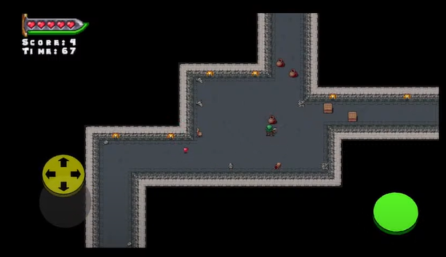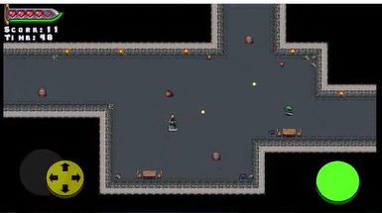

Pros:

* The text has cool effect and colour gradient
* The button is 3D design
* The wall and the floor are easily distinguished
* Lots of additional/ extra entity in the game
* Tutorial is easy to follow and understand the mechanics
* Count down timer. Player must finish the game before the time runs out and additional score is reward for the remaining time
* The game will automatically zoom-in in tiny area
* Random box is generated contains loots
* The monster shoots fireballs which are predictable and can be aFunction by controlling the movement of the player
* The health item on the floor is available to pick up and recover the health
* Hint pop up when there is an update on effect or health

Cons:

* The joystick does not response instantly. It needs times to “accelerate” the player movement
* There is no setting menu, login menu, save menu and pause menu
* If you switch out and back to the game, you have to restart your level because it forces quit and doesn’t save the progress in the background
* If you get hit, you can’t move. Not ideal when escaping from a monster
* No instruction on escaping the map no direction, no exit and mini-map
* The distance of monster attacking is unclear
* No way to counterattack of the fireball dispenser

Game 5- Maze Runner 2D

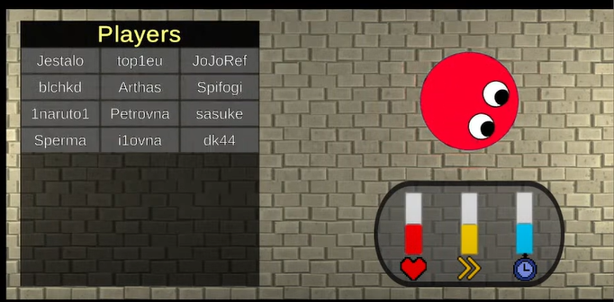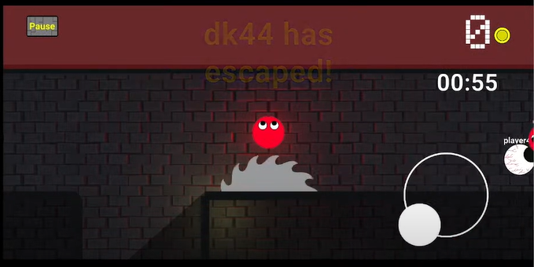

Pros:

* tutorial at the game start – (show dialog box and visible when introducing the UI)
* Exploring torchlight, entity is hidden unless the torch is on
* The lighting is varied in different area
* Use the “eye” to tell player the direction of the character
* Trap included in the game (circular saw and pressure plate which is hard to see
* There are coins available to collect in the game
* One way movement only (like ice skating rink)
* There is no pause menu during the game
* The joystick which controls player movement is located at right hand side.
* Vending system to trade character skin with coins
* Every character has different ability (health, speed and time level)
* Character preview on waiting screen
* System broadcast on the update of the game
* Power up could slow other player down
* Able to continue the game even if the player is dead by watching ads
* Poison zone like PUBG is included to limit the area of player is included

Cons:

* Fake multiplayer game (use AI moving algorithm to move)
* The time limit is too short
* The circular blade trap is too fast and large. Very hard to escape from the trap
* The trap should have more time for player to react
* No pause menu button

Conclusion: This game should have a pause button. It is not a multiplayer game and it is paramount for people who play in their spare time. However, the game is quite fully developed, the AI script movement acts like a real player. Although it has a tutorial at the beginning of the game, the direction of the map is unclear and you are unable to reach the finish line. Adding a mini-map could help the player to navigate a lot better.

Game 6 – Labyrinth Legend

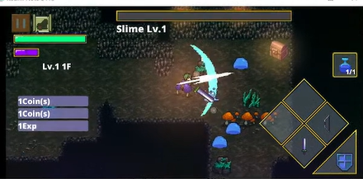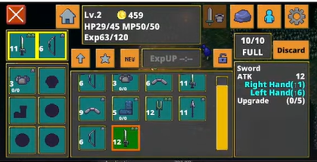

Pros:

* Selection of language
* Google play integration reduce the time of register and login
* Personalize the game by using the name user login
* Setting is all-rounded, including audio, field of view and quality setting
* Statistics and achievements are available in the setting menu
* Layout and size of joystick can control by the user
* The game store the game session both local and cloud service
* Staff credit included in the game
* The storyline of the game is mentioned before the game start
* The control is responsible and interactive
* The character movement is fast and footprint is shown for realistic
* The joystick is not fixed in the same location
* Predictable and aFunctionable monster attack by using (!) to alert player
* The damage deal to the monster is high and
* The attack range is acknowledge with the animation
* Able to attack from the monster with no recharge/ cooldown needed
* There are shield as a power-up to block any damage from the monster
* Different ways to restore health by drinking elixir and on next game start
* Could replace another weapon like bow in inventory menu
* Weak but abundant monster
* Monster will drop the key requires to open the door
* Monster health bar is always shown on top of the monster
* Monster will only chase and attack player within a certain range
* Knockback will be perform when monster hurt the player
* Hint is pop up with news on inventory or experience earned
* Use portal to teleport to the next level
* Random loot from the ground by removing the grass with sword
* Inventory includes sort function
* A lot of NPC provide interaction dialog and objective to player
* Comparison on damage and speed of two different weapon is shown
* The pause menu separate setting and inventory using multi- tab
* Monster will drop some coins after it is dead

Cons:

* Setting could be organised
* The setting menu and inventory is combined with the pause menu
* No map to solve
* There is only one objective and player cannot reach the escape of portal before killing all of the monster

The gameplay of this game is underrated and combat system, monster behaviour and the setting of this game could be a reference to my game. The joystick could be dynamic so it is more user friendly to mobile player. There should be different weapon choice, comparison between you weapon and inventory sorting should also include in my game. However, I will add more objective and power up to my game to enhance the gameplay of my game.

Game 7 – Stumble guys

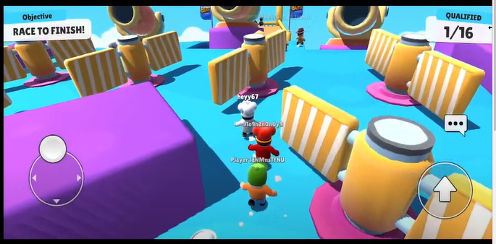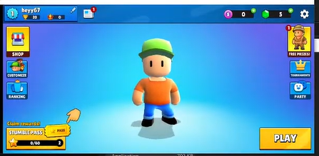

Pros:

* Multiplayer is smooth and responsive in real time
* The game session could be self hosted by the player
* The host of the session will be transfer if the original host is left
* The achievement system is fully integrated to the main
* Personalise by changing the name and different clothes customization
* Shop system integrated with daily bonus – attract player to login and play everyday
* Leader board system included and can be sort by region of the world
* Maps are randomly selected with animation
* Realistic physic system and animation of player is added
* The cartoon UI is user and child friendly
* Powerup are predictable by the texture (bouncer, spring or cannon)
* The weather affects the gameplay (Icey weather will walk slippery)
* Game-over page will show the reward gained including the placement, coin and experience
* The game is straightforward and tutorial is not required for this game

Cons:

* Requirement of stable network connection
* The trap can only aFunction precisely and with skills

This game focuses on the multiplayer experience and realistic physics system which inspire me on the multiplayer session of objective and the realistic movement player needed. Leaderboard sorting is also a good idea as player would like to know different performance and statistic on different criteria

### 1.2.1.5 Prototyping

1. Movement

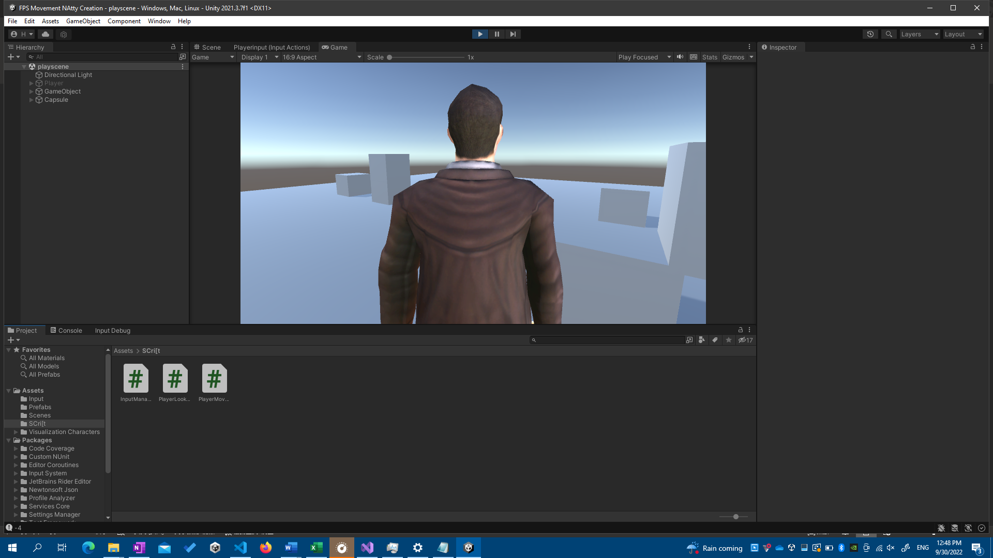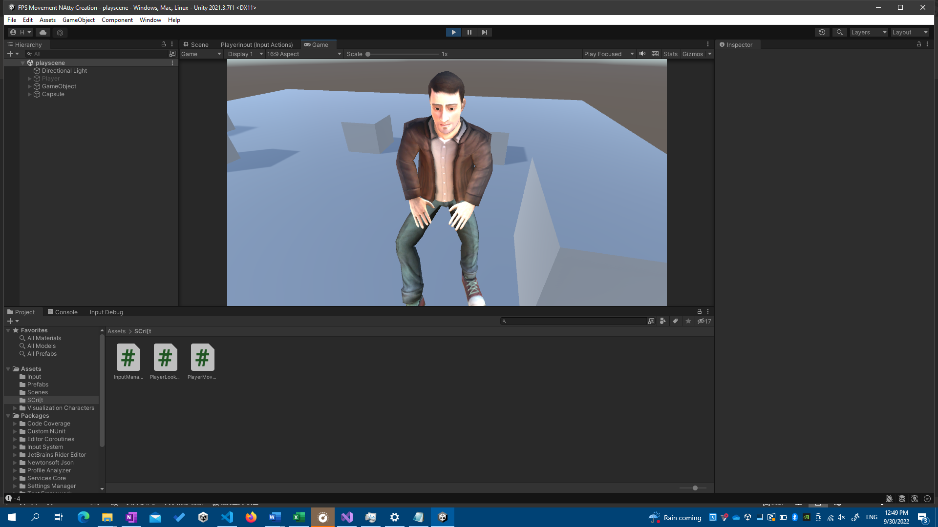

When I started coding my project, I needed to get comfortable with the tools, which involve the C# language and the Unity Engine. In order to move and gaze about, I have followed a lesson on movement control using a computer mouse and keyboard (W, A, S, D, and spacebar). To demonstrate what I learnt from the instruction, I have also implemented a jump action. When a movement, such as walking or jumping, was triggered, animation was added and altered. To make a seamless transition, I utilised Unity's built-in Finite State Machine for Animator.

1. maze game (PC)

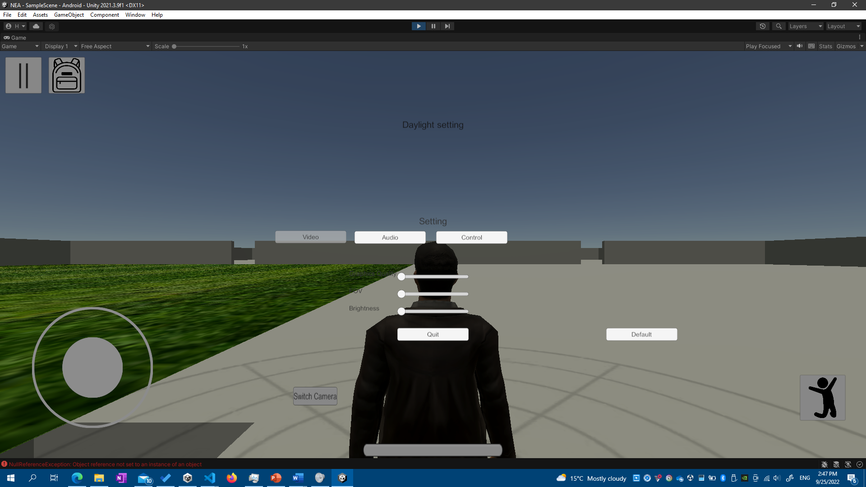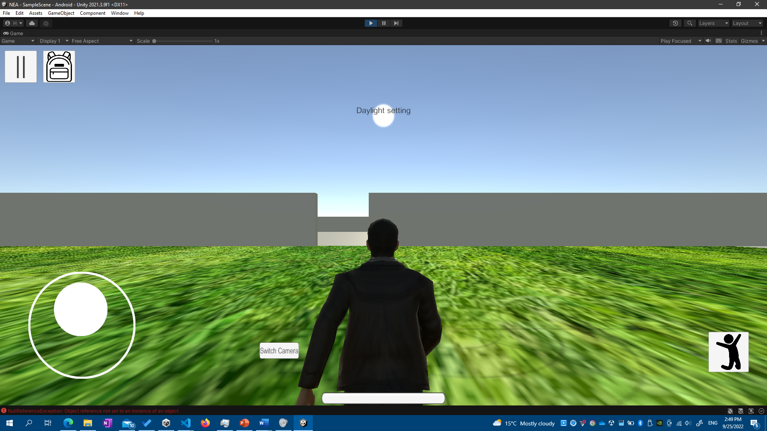

This is my 3D labyrinth game prototype. This map was created using the modelling software SketchUp. The model had been successfully imported into Unity. Except for the texture, the model is totally compatible with Unity Engine. However, a native Unity model needed to be replaced so I may apply texture to different parts of the model. This prototype includes the Main Menu, Pause Menu, Login and Registration Menu, and Inventory UI. This basically entirely covers the Interface of my game.

The setting function for customising the game in player presence is operational. There are multiple tabs for various setting categories. The joystick size and rotation sensitivity may be adjusted using the slider. To make this game mobile device suitable, the movement is modified from the sample game, and a joystick and detect screen touch input are added to make the game more touch-friendly. The joystick allows the character to move/walk and spin around by moving inside the right half of the screen. The actual game, like this game and the game above, will include animation.

## 1.2.10 Analysis Data Dictionary

|  |  |  |  |  |  |
| --- | --- | --- | --- | --- | --- |
| Field Name | Field Purpose | Field Type | Field Size | Example Data | Validation |
| Record_ID | Index of all data | Int | 11 | 0,1,2 | Primary Key, Unique |
| email | The login detail of user | String | 255 | [admin@shalev.ml](mailto:admin@shalev.ml) | Not blank, Unique |
| password | Login to verify user | Varchar | 255 | Ss12354678 | Not Null |
| username | Display playerName on leaderboard | String | 255 | Shalev Lau | Not Null, Unique |
| levelName | The level name | string | 50 | Easy | Not Null |
| multiplier | The reward of difficulties | float | 11 | 1.4 | Not Null |
| score | The number of monster player has killed | Int | 11 | 8 | Not Null |
| time | Time required to solve the maze | int | 11 | 50 | Not Null |

## 1.2.11 Data File Size /Volume

The total database file size including the data, index, overhead. The file size of Progress table including five 11-digit of integer requires approx. 8.0 Kibibytes. The file size of Player table which includes four 255-digit of string, one 20-digit of string and one 11-digit of integer primary key requires approximately 3.0 Kibibytes. The file size of Level table including 11-digit of integer primary key, float and 50-digit of string needs 2.285 Kibibytes.

## 1.3 Specific Objective

### 1.3.1 Splash Screen

1. The name of the game should be appear before the game starts
2. The name of the producer should appear before the game starts
3. A warning of copyright of the game needed to be shown in the loading screen
4. A Loading Screen should be shown after the names above is shown
5. Loading Screen needs to be clickable after the names shown
6. Main Menu should be loaded after the loading screen is clicked

### 1.3.2 Main Menu

* + 1. A introduction image should fade out before the Main Menu is shown
    2. A pop-up screen should be pop up to alert player to login to save the progress into the Leaderboard
    3. There should be 5 buttons on the screen, including Continue, Start Game, Leaderboard, Setting and Quit
    4. All 5 buttons listed in 1.3.2c should be able to open different panel when clicked
    5. The continue button should be disable if the game haven’t run before
    6. Login state should be on main menu remind the player which account it is logged in



### 1.3.3 Setting Screen

* + 1. Login Screen should pop up to make it more convenient to login
    2. The Setting Screen should have 5 categories, including Audio, Video, Control, Graphics and Login
    3. All 5 categories tabs listed in 1.3.3b will show corresponding setting category
    4. Default value should be set before if setting is never open/ configured before
    5. Video Option should contains the Field of View of camera and minimap setting
    6. Audio Option should contain SFX and Music Volume Setting
    7. Graphics Option should contain settings of Quality level and brightness
    8. Control Option should contain settings of the size of joystick and Sensitivity of turning around
    9. Settings value should be loaded after the Setting Panel is closed
    10. Value of settings should be saved in order to retrieve on next game runs

### 1.3.4 Quit Panel

* + 1. The quit panel should show 2 buttons including Quit Button and a Cancel Button
    2. The game should be quitted after Quit Button mentioned in 1.3.4a is clicked
    3. When cancel button is clicked, quit panel is disabled and return to main menu

### 1.3.5 LeaderBoard



* + 1. A leaderboard panel and 4 selection columns including player username, level, score and time used needs to be available for player click
    2. An instruction will pop up talking about the sorting and statistics players can access
    3. Different columns will be sorted using merge sort based on user selection
    4. Leaderboard data needs to be automatically updated
    5. When player performance button is clicked, the level score of each player will be shown
    6. When all statistic button is clicked, best player of each level and average score will be shown

### 1.3.6 Login & Register

1.3.6.1 Login

1. email field must not be blank
2. password must be longer than 8 characters
3. wrong password prompt will be shown if the password or username entered doesn’t match with the detail in database
4. A login successful prompt will be shown if both password and username entered correctly and match with the data in database
5. When the close button is clicked, the login screen will be disable
6. Login state will be automatically update in the main menu screen
7. The login state will be saved in local file and automatically login in when game restarted

1.3.6.2 Register



1. Username field must not be blank
2. Username field must not be more than 20 characters
3. Email field must include an @ symbol and follow correct email regex
4. The password field must not be blank
5. The password field must be more than 8 characters
6. The password field must contains one uppercase, one lowercase and one number
7. The password field must not be contains common character such as “1234” and “pass”

1.3.6.3 Welcome back

1. If the game is logged in, the welcome back screen will replaced the login screen
2. The username logged in will be shown on the screen.
3. The play button and the close button will be confirming the login detail is corrected.
4. The login state will be cleared and return to the login screen if the not you button is clicked

### 1.3.7 Start Game Save Slot Selection Panel

1. Data of the slot will be deleted and the continue button will be disable in the main manu



1. Pop up will show the detail of last play and the current score and time used to spend on the game and index of the slot



1. Game Save Status can be delete through a cross button and the continue button will be disable if deleted successfully
2. Game will start when either slot is clicked , loading screen will appear

### 1.3.8 First Time

* + 1. Animation should played after the screen is loaded
    2. Difficulty panel should appear after the animation ended
    3. There should be 6 level in the difficulty selection

### 1.3.9 Character Selection

* + 1. Player can choose from the 4 different characters
    2. Detail of player will shown when the pop up button is clicked
    3. Main menu will be returned after the player has confirmed their character selection

### 1.3.10 Maze Generation



1. The maze should generate and saved before the game start
2. The maze will generate randomly in every new game
3. The maze will be more complex if the level increase

### 1.3.11 Loading Screen

1. Loading bar and text will indicate the progress of scene loading
2. Loading text will be change every 3 second to entertain players

### 1.3.12 Main Game

1. Player is able to switch between the 1st and 3rd person camera
2. Left joystick needed to be able to control the movement of character
3. Right joystick should be able to control the direction of movement
4. Jump action will be performed and movement will disable when the jump button is clicked
5. Crouch action will be performed and movement will be slow down when the crouch button is clicked
6. The animation of the player will loop between walking and idle
7. The time of the game will be shown on the screen
8. The kill count of monster is shown on the screen
9. The camera will automatically follows the player

### 1.3.13 Weapon

1. The attack icon will change to the current weapon selection
2. When one of the weapon slot is clicked, current weapon will change to the clicked weapon
3. When the player collide with the moving blade, it will deduct player health
4. The axe will throw forward when axe selection button and attack button is clicked
5. Trap will be placed when current weapon is set to trap and attack button is clicked

### 1.3.14 Monster

* 1. The health of the monster will be deducted when the axe or trap collided
  2. The monster will be dead when the health is below 0 and not dealing any damage to player
  3. When the monster spotted and moving toward the screen, a warning banner will pop up



* 1. The monster will only chase player within certain distance
  2. The monster will start attacking player within a small distance
  3. When the monster is attacking player the player health will be decrease
  4. Random type of monster will be spawn every day
  5. Monster should use shortest path algorithm to chase player
  6. The monster should drop a key or other loot when they are dead
  7. The monster health is shown on the top of the monster



* 1. The monster will be crushed to dead if it doesn’t have enough time to pass through the gate of the maze
  2. Monster attack will be cooled down before the next attack



### 1.3.15 Maze

* + 1. One of the gate will be after the game started
    2. The next opening gate will be changed every 24 hours
    3. When the skip button is clicked, the next opening sequence will be opened
    4. The maze opening sequence will be shown on the screen
    5. The player should not be able to pass through any wall and maze in this game
    6. The maze should contain a walkable path to reach the exit side

### 1.3.16 Exit

The exit is located in one of the maze zone only



The exit gate should be able when the player typed in password correctly



Player should hold the key in order to make the password screen visible

The progress of the game will be deleted as the level is finished

### 1.3.17 Health

* + 1. Health will be +10 when the heal button is clicked
    2. At the start of the game, the health is at the maxmum value
    3. Animation will be played when the health value is changing
    4. Gameover screen will show up when the player health is less than 0

### 1.3.18 Pause Menu

* + 1. The menu will show up when the button is clicked
    2. There are 2 buttons in pause menu, return and quit the game
    3. The pause menu will close when the return button is clicked
    4. When quit button is clicked, it returned to the main menu and progress will be saved in local file
    5. The time counter of main game should be paused

### 1.3.19 Game Over

* + 1. The screen will contain following elements, whether the player passed, the time used by the player, the difficulty level and the monster player killed and continue button.
    2. Login screen may appear if the player haven’t login yet
    3. The close button of login screen is disable to forced player to login and save the score

## 1.4 Additional Objectives

### 1.4.1 Path Finding

1. The mini-map should show the path of escaping the maze using Dijkstra

### 1.4.2 Visual Improvement

1. Blood effect will show up when the monster is hurt

### 1.4.3 Monster

1. The monster should setup some trap on the floor that constantly deals damage to player

### 1.4.4 Special Feature

1. Power-up should be included which stealth, speed increase and strength increase
2. In sunny day, the player will received speed boost
3. Footprint should be left on the floor

### 1.4.5 Quest System

* 1. Objective and quests should be added in the game
  2. Rewards of weapon and coins should be given after finishing the quest

### 1.4.6 Achievement System

* + 1. Achievement and rewards should be given once player achieve an achievement
    2. The count of achievement target will be increase polynomial

### 1.4.7 Inventory

* + 1. The inventory panel should be open when inventory button is clicked
    2. The inventory panel should include 4 button search, sort, slot1 and slot2 buttons
    3. The inventory should include crafting table when the player is near to a crafting table
    4. The crafting table should support undo function

### 1.4.8 Pick Up

* 1. When the player walks into the range of the item, pickup panel will pop up
  2. When the pickup panel popped up, player can pickup the item listed if the inventory is not full
  3. When the player dropped the item, the item will left on the ground

### 1.4.9 Music

* 1. The Setting should be able to change the volume of music
  2. SFX and background music are separated
  3. SFX should be played when the player get hurts and movement has done
  4. Music should be played in the main menu

### 1.4.10 Rewards

* 1. Rewards is given for weekly login
  2. Bonus box (loot) is given at the game start

### 1.4.11 Online Service

* 1. Login with social media SSO should be an alternative way to login the game
  2. Option to share the screenshot to social media should be added
  3. Current game state should be automatically upload to Google Drive or OneDrive

### 1.4.12 Multiplayer

* 1. More than player can be played and co-operate in the same game session
  2. The player should be the host of the game server
  3. If the host player has left the game, the host will be transferred

### 1.4.13 Ghost System

* 1. A splitting image of player in the previous round will be shown as a semi transparent model in the game

### 1.4.14 Wooden box

* 1. Wooden box provide 16 slot for storing extra items player has
  2. The wooden box must be able to locked to prevent other player grief from the box

### 1.4.15 Vending Machine

* 1. Vending machine should be include in the pause menu
  2. Player can spent their coins in the vending machine buying rare weapon, special character and medicine

### 1.4.16 Terrain

1. The terrain amplitude is generate using Perlin noise map

### 1.4.17 Action Replay

* 1. There is a rewind button to go back to previous state
  2. Playback is available for killing the boss monster

### 1.4.18 Player Profile

* 1. Player name, XP and level will be shown on the player profile page

### 1.4.19 Database

* 1. Player password will be stored in hash and salt to enhance the security of database

## 1.5 Proposed solution

My project will be implemented by C# and Unity Engine using Visual Studio Code and JetBrains Rider as my IDE. Unity Engine is a powerful tool to create either 2D or 3D games and is interchangeable. Secondly, C# and Visual Basic shares the same library using Microsoft .NET framework which the syntax and logic is similar, so it is easier for myself to learn C#. Thirdly, Unity support multi-platform like android and WebGL so I don’t have to switch engines to switch platform. Lastly, there are a lot more tutorials and resources for Unity compared to other game engines like Unreal Engine.

# 2. Design

## 2.1 High-level overview

### 2.1a System flowchart (whole diagram)

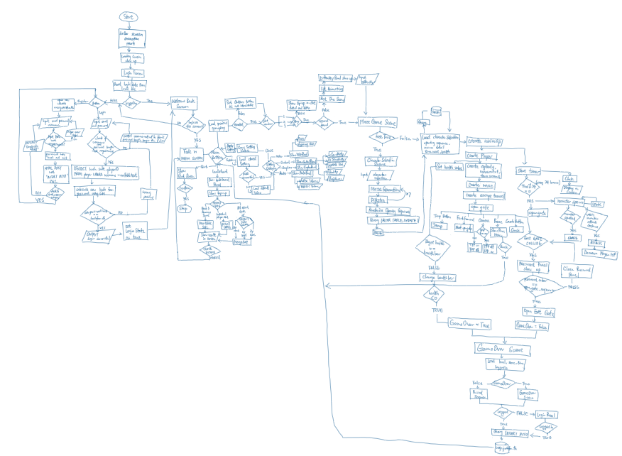

### i) Login Screen and splash screen

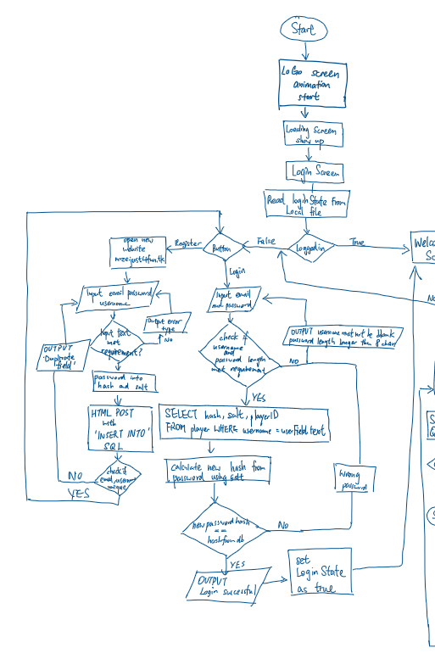

### ii) Main menu screen (Leaderboard, Setting, Quit and Start Game)

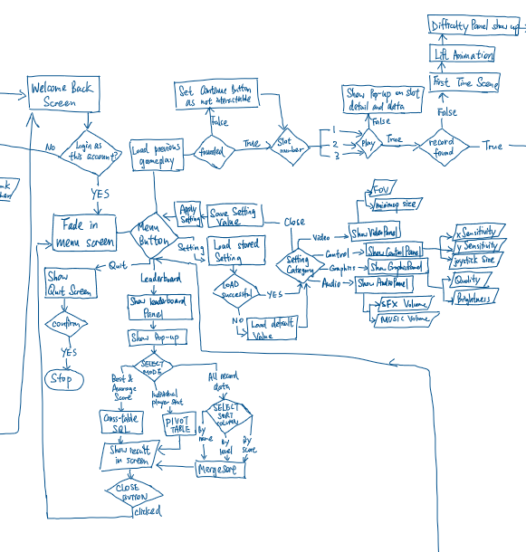

### iii) Maze Game

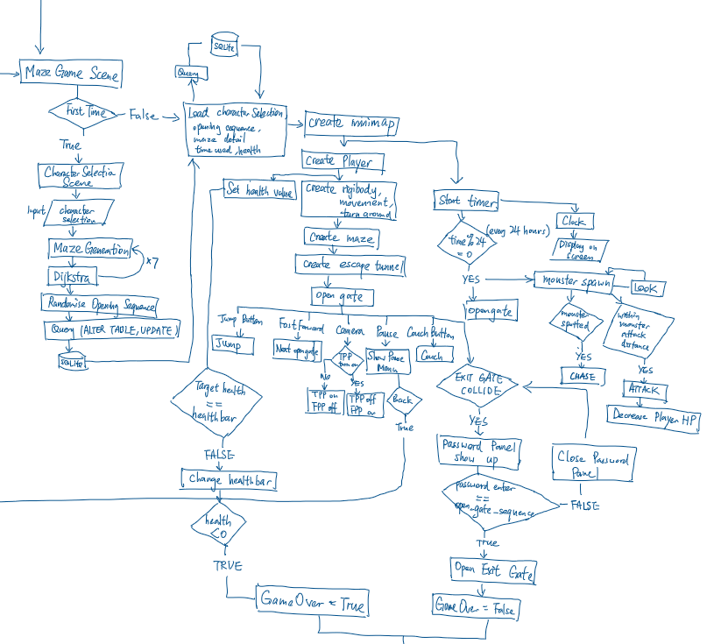

### iv) Game Over Screen

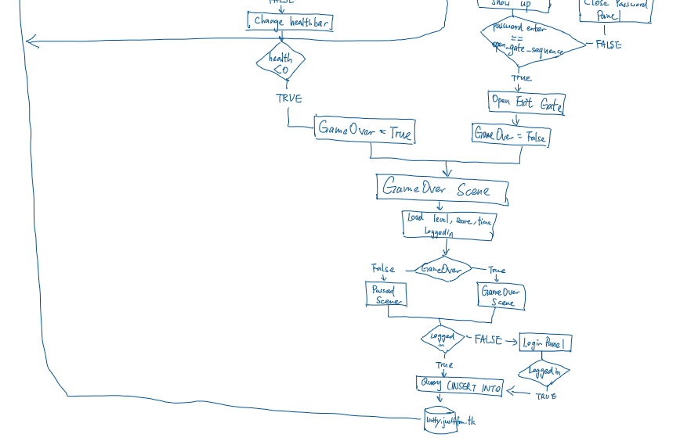

### 2.1b Data Flow Diagram

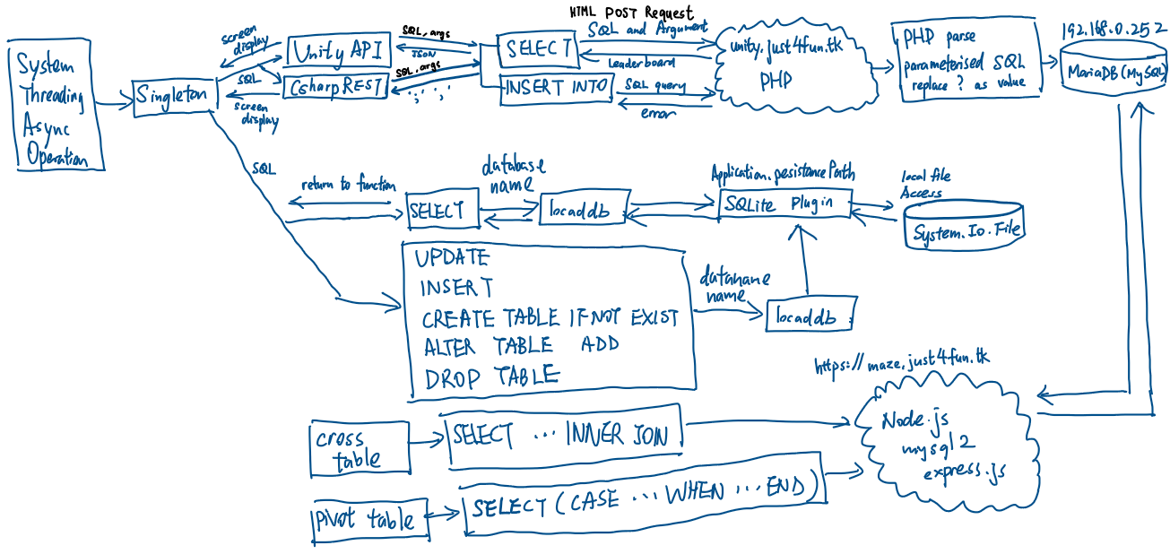

## 2.2 Modular in structure of system

### 2.2a Site map

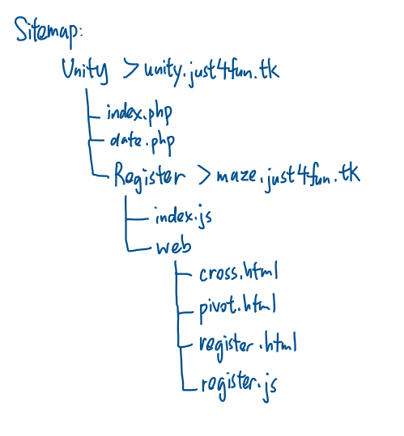

### 2.2b System chart

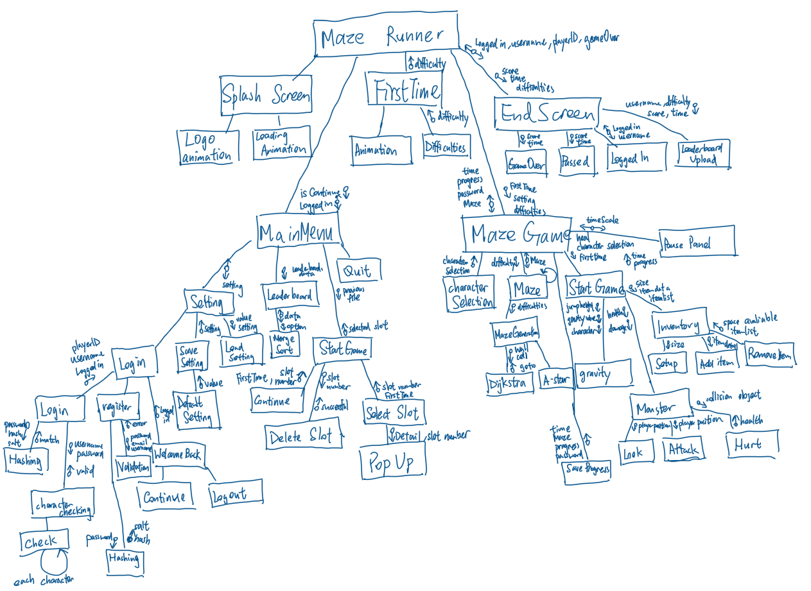

### 2.2c Table of Class

Algorithm

this folder contains all useful algorithms such as sorting and hashing. These algorithms will be easily accessible by create a new instance using composition class relationship.

|  |  |  |  |
| --- | --- | --- | --- |
| Class | Description | Attributes | Methods |
| BinarySearch | This class contains binary search function which user enter the list and search item and it return the position of the list. |  | Search() |
| Checking | This class contains character checking for login screen for data integrity |  | Check() |
| CQueue | This class contains a combination of circular queue and linear queue | _queue :int []  _circular :bool  _frontofqueue :int  _rearofqueue :int  _numberofitem :int | CQueue()  Enqueue()  Dequeue()  Peek() |
| gravity | This class contains a base function of the gravity function for both player gravity and entity gravity | _grounded :bool  gravityacceleration :float  _jumpgravity :float  _gravityspeed :float  _orginal :Vector3  _isUpJumping :bool | Update()  gravitySetting() |
| hashing | This class contains a hash algorithm converting string into integer using hashing algorithm and store in hash table. Linked list is used when hash table has more than one same key value |  | Convert()  HashTable() |
| lList | The purpose of the linked list is to serve hash table to prevent error happened if the hash table has more than one key value(index) | dataNmemoryloc :int  Headloc: int | lList()  AddHead()  GetNextPointer()  GetBlockData()  AddFoot()  Search()  Traversal()  SearchPriority()  AddWithPriority()  AddValue() |
| MergeSort | This class contains a merge sort algorithm. It require input of a list and order column then uses recursion to divide and conquer the data |  | MergeSort()  Merge() |
| Projectile | This projectile inheritance from the gravity class. It is used for entity (axe, weapon) gravity | Yacc  Speed  Gravity  Velocity | Update()  Shoot() |
| Stack | This class contains a stack function which follows First In Last Out. And include a contains function to search through the stack | _stack_arr :object[]  _pointer :int | Stack()  Push()  Contains()  Pop()  Peek() |

First Time Scene

The following scene only runs when the game slot is new

|  |  |  |  |
| --- | --- | --- | --- |
| DifficultyPanel | This Panel show up after the list animation has been played. Player choose from 7 Level options and continue to main game | Diffi : Slider | Start()  Load()  Update() |
| FirstTimeMan | This script start the animation when the scene loaded | Loader :GameObject  _animator :Animator | Awake()  Update()  LoadScene() |

Maze Scene

|  |  |  |  |  |
| --- | --- | --- | --- | --- |
| CharacterDataBase | This class uses for storing multiple characters | | Characters :characterSpecification[]321 | GetGameObject() |
| characterSpecification | This class is a serializable object which uses as a template of data structure | charImage :Sprite  charName :string  charDescription :string  speed :float  InventorySize :int  actualObject :GameObject | |  |
| Charcard | This class store in character selection card to deal with the button onClick in GameObject | Popup :Button  Selection :Button | |  |
| Inventory | This class manage the player’s inventory. | InventoryItem :Structure  itemDetail :item  quantity :int  inventoryItems :InventoryItem[] | | Start()  Setup()  Pickupitem()  Removeitem() |
| Item | This class is a serializable object which provide and template on structure of data storing. | maxStack :int  itemImage :Image  obj : GameObject  itemName : string  Weight :float  Damage :float  Weapon :bool  Throwable :bool  Shootable : bool  pickupScript : PickUp  triggerradius : float | | OnEnable()  OnTriggerEnter()  OnTriggerExit() |
| ItemsObject | This class create a instance of item and run initialise function of an item |  | | Start() |
| Slot | This class is located in the slot inside the inventory. It define the behaviour of the slot | mainSlot :bool  itemdetail : item  stacksize :int  stacksizeUI :TMP_Text  itemImage : Image  frame : Image | |  |
| Djk | This class contains a Dijkstra algorithm and return a list of walkable shortest path | Wall: List<string>  Cell :MazeCell[]  Unvisitedcell | | Djkinit()  Search()  Calcost()  Obcheck()  Sidebar()  AvaliableCell |
| Goto | This class receive the path from Dijkstra and control the movement of monster | Shouldmove :bool  Pos: Vector2  Speed :float  Hello : GameObject | | Goto()  Update()  Move() |
| Maze | This class create a basic model for maze generation to start | _sizeX :int  _sizeZ :int  _cellPrefab :GameObject  _walls :List<string>  _cells :Mazecell[,]  _wallPrefab :GameObjectq | | Generate()  CreateCell() |
| Mazecell | This is the class in each cell in the maze. It store variable for Dijkstra, A* and DFS maze generation | Visited :bool  Dir : List<string>  Djkmincost :float  Djkprevious : Vector2  Djkvisited : bool  djkdirX : int[]  djkdirZ : int[]  ghost :float  hcost :float  fcost :float  Aprevious :Vector2  Avisited: bool  Adir: bool[] | |  |
| MazeGeneration | This class use DFS as algorithm of maze generation by eliminating the wall | _myParent : Transform  Wall : List<string>  Cell : Mazecell[,]  Stack1 :Stack | | Run()  BuildMaze()  Checkdir() |
| WallCell | This class contain the behaviour of the wall |  | | Start()  Update |

Monster

|  |  |  |  |
| --- | --- | --- | --- |
| BigGreiver | This class is derived from monsterbehaviour and adjust the damage to fit as Large griever |  | Update() |
| Blade | This class control the blade spinning and deduct player HP | rotateSpeed : float  Scale : float | Start()  Update()  OnCollisionEnter() |
| IMonsterConfig :interface | This interface contains the basic method of monster | Health: float  Location : Transform | Look()  Chase()  Dead() |
| MonsterBehaviour | This class contains the default monster behaviour | _health : float  _location : Transform  _monsterloc : Transform  char1: GameObject  _animator :Animator  isDead : bool  isRunned :bool  _ins : MazeManager | Awake()  Start()  Update()  Look()  Chase()  OnCollisionEnter()  Dead() |
| SilverFish | This class is derived from monsterbehaviour and adjust the damage to fit as silverfish |  | Start() |
| SmallGriever | This class is derived from monsterbehaviour and adjust the damage to fit as small griever |  |  |
| Movement | This class handle the left joystick as the movement of player and derived from gravity class for gravity of player | Joystick :Joystick  Move : Vector2  Wallspeed : float  isCrouching : bool  crouchwalk : float  crouchheight :float  jumpheight: float | Start()  Update()  Touchmovement()  Crouch()  Jumpbutton() |
| PlayerAction :Interface | The interface contains the basic method that playerSetup should cotains |  | PlayerMove()  PlayerLook() |
| PlayerSetup | The class contains the setup of the basic feature including movement and turning around of the player | Timer : float | Start()  Update() |
| Switchcam | This class handle the switch button on switching perspective of camera | _cams :Camera[] | ChangeCamera()  Start()  Update() |
| toucharea | This class control the turn around joystick on the UI | Touch :GameObject | Start()  Update()  Raycast()  GetTouch() |
| Turnaround | This class handle the turn around of the player | _cam :Camera  Dyn_joy : Joystick  xSpeed :float  ySpeed :float | Start()  Update() |
| Circular | This class handle the outermost wall and the position of exit tunnel | Center :Vector2  Radius : float  StartingPoint : Vector2  meterWidth: float  repeat :float  angle :float  objectToRotate: GameObject  rotationPoint :Vector3  rotationSpeed: float | Start()  Rotate() |
| Clock | This class handle the daylight and the time of the game. | Light :Light  Rotate :Vector3  Time :float  Text :TMP_Text  Date :int | Start()  FixedUpdate() |
| Escapecontroller | This class retrieve the game data after gameOver and show on screen | Time :TMP_Text  Monster : TMP_Text  Difficulties : TMP_Text  gameOverPanel : GameObject  PassedPanel :GameObject  mainPanel : GameObject  loginPanel :GameObject  CloseButton : Button  Username : string | Start()  Update()  Upload()  ContinueButton()  Back() |
| exitTrigger | This class handle the change of scene in exit tunnel | Exit: GameObject  passwordPanel : GameObject | OnTriggerEnter()  DestroyWall() |
| gameOver | This class handle the UI of the gameOver screen |  | OnTriggerEnter() |
| Heal | This class handle the heal button by increasing player HP |  | Start()  Update()  OnTriggerEnter() |
| mainCharacter | This class handle the weapon selection and represent the character. | currentSlot |  |
| MazeManager | This class control most of the function in the game. Including maze generation, character and the exit gate of the game and game save feature. | characterUI : GameObject  empty : GameObject  characterSelectionUI : GameObject  mainchar : GameObject  cams :List<Camera>  player :GameObject  character : characterSpecification[]  currentselection : int  currentAttackSelection :int  selectcharButton :Button  invent :Inventory  _angle : int  _monsterKilled : int  Open_gate_order : CQueue  Opennow:bool  Playerpos :Vector3  _setting :Setting  _password : string  Sprites : Sprite[]  spriteSlot1 :Sprite  spriteSlot2 :Sprite  attackSelection : Image  startAt : TMP_Text  NextGate : TMP_Text  Nextmonster : TMP_Text  Counting :TMP_Text  monsterPrompt :TMP_Text | Dead()  spawnMonster()  Awake()  MonsterPrompt()  Start()  ShowCharacterPopUp()  Selection()  Maze()  StartGame()  OpenPassword()  FirstTime()  SaveLevel()  Attack()  changeAttack()  heal()  openGate()  Back()  UpdateScore() |
| Minimap | This class handle the mini map of the main game | Minimap_cam :Vamera  Texture :RenderTexture  Img: RawImage | Setup() |
| onLoadMaze | This class initialise the game when the maze game loaded |  | Awake()  Update() |
| Open_gate | This class handles the maze gate of the game and the animation of opening | M_left: Transform  M_right: Transform  Back; Transform  Open: bool  Speed: int  mVecRIght_OpenPos: Vector3  mVecRIght_ClosePos: Vector3  mVecLeft_OpenPos: Vector3  mVecLeft_ClosePos: Vector3 | Update() |
| passwordPanel | This class handle the exit gate of the maze by user entering password | Inputtext :TMP_InputField  Password :String  Done :bool | Start()  Update() |
| Pause | This class handle the pause menu and the option provide in pause menu | Leader : LeaderBoarddata | Awake()  Start()  Update()  timeChange()  Open()  Close()  SettingPause()  LeaderboardPause()  Back() |
| PerlinNoiseMap | This class is used for creating the uniqueness of the safe zone area | Width: int  Height :int  Scale :float  Persistence :float  Lacunarity : float  Octaves : int  noiseMap: float[,] | Start()  Generate() |
| PickUp | This is the handling class for the slot of pick up panel | Items : List<Item>  _selectionSlot:PickUpSelectionSlot | Start()  Update()  Toggle |
| PickUpSelectionSlot | This is the User Interface handling for the pick up class |  | Start()  Toggle() |

MainMenu:

|  |  |  |  |
| --- | --- | --- | --- |
| MenuPanels | This is the abstract base class for menu enable. | _menu :GameObject | Awake()  Start()  ShowHide()  Function() |
| QuitMenuPanel | This class handle the quit menu |  | appQuit() |
| SlotSelectionPanel | This class handle the start game button and detect the save existence | filePath | Start()  SavefileSelector()  DeleteSlot()  popUpDetail() |
| AudioSettingPanel | This class represent the audio setting panel |  | Start() |
| ControlSettingPanel | This class represent the control setting panel |  |  |
| GraphicsSettingPanel | This class represent the graphics setting panel |  |  |
| Setting | This class load and save the setting stored in local file and apply setting in the game | Dbname :string  filePath :string  xSenS :Slider  ySenS :Slider  MusicVolS :Slider  sfxVolS :Slider  cameraFOVS :Slider  minimapSizeS :Slider  joystickSizeS :Slider  graphicQualityS :Slider  brightnessS :Slider | Start()  Setup()  LoadSetting()  SaveSetting()  UpdateSetting() |
| SettingManager | This class handle the buttons of the setting tab | _audioPanel :AudioSettingPanel  _videoPanel :VideoSettingPanel  _graphicPanel :GraphicsSettingPanel  _controlPanel :ControlSettingPanel  buttonObject :GameObject  buttons :Button[]  path :TMP_Text | Start()  Login()  AudioAction()  VideoAction()  GraphicAction()  PanelHide()  QuitSetting() |
| VideoSettingPanel | This class represent the video setting panel |  |  |
| LoadingCircle | This class control the rotation of the loading circle |  | Update() |
| SplashScreen | This class control the behaviour of the splash screen | allowChange :bool | Start() |
| continuePanel | This class handles the button action after gameOver’s continue button clicked | continueButton :button | Start()  ClosePanel() |
| Leaderboard/ leaederslot | This is the serialise object that provide the column of object storing | Username :string  Level :int  Score :int  Since :int |  |
| LeaderBoarddata | This class get leaderboard data from the database and sort it. | Slot :Transform | External()  Start()  Sorting()  ParseJSON()  WebLeader()  GetData()  printData() |
| loginState | This class handle the login of the game. Also the login, register and welcome back panel. | loginButton :Button  emailField :TMP_InputField  passowrdField :TMP_InputField  info :TMP_Text  welcomebackPanel: GameObject  loginPanel :GameObject  notMeButton: Button  playButton :Button  getusername : TMP_Text  username : string  ID :int | Start()  OnEnable()  welcomeBack()  Play()  NotYou()  Register()  Login()  infoHandler()  hashFunction()  hexToDec() |
| MainMenuManger | This class contains the basic operation of the mainmenu screen and handle the main menu buttons | _manSfxPlay :bool  _manAnimator :Animator  Fade :Image  _continuePanel :GameObject  menubuttonSfx :List<AudioClip>  manSfx : AudioClip[]  quitButtonSfx : AudioClip  menuButtons : GameObject  _menuSekectorButton : button[]  _settingManager : SettingManager  _quitMenuPanel : QuitMenuPanel  _leaderboardPanel: LeaderBoarddata  _slotSelectionPanel : SlotSlectionPanel  Panels : GameObject[]  _loginState: loginState  continueFrom :int  loginState: TMP_Text  continueButton: Button | Awake()  continuePrompt()  menuSelectorButtonAction()  Update()  PlaySound()  Move()  ShowQuit()  ContinueButton() |
| onLoadMainMenu | The class contains actions that needs to be taken at the start of the game |  | Awake()  Update() |

Universal script: (Singleton)

Singleton is a script that set as a universal static script which means it can be accessed anywhere without decalacfed and implement the script, it wont be destroy in the whole game and only 1 singleton will be allowed as it is the “main controller/ Access Point” of the game. Singleton hide the complexity of the code by providing Function/Sub-routine for code that needs to be run repeatedly and because of the global scope of GameObject. Data inside Singleton can also act as a carrier to different scene to reduce the complexity of code.

|  |  |  |  |
| --- | --- | --- | --- |
| Singleton | Handle game menu and function button on screen and change currency and lives.  Static class allows class being called anywhere in other script | fadeSpeed : float  LocalDB : localSqlite  UnityAPI: UnityREST  CsharpAPI: CsharpRESET  Fade: Fading  AudioPlayer: AudioService  HealthClass: playerHealth  LoadScreenclass: LoadingPanel  popup: PopUpPanel  _FirstTime : bool  _loadNumer: int  _instance :int | Start()  Init()  ShowDetail()  ShowError() |
| Sound Manager | This class handle the sound input of the whole game. | _music :AudioSource  _sfx :AudioSource | OnEnable()  PlayMusic()  PlaySfx() |
| Pop up panel | This class handle the pop up name, image and details. | _itemImage :Image  itemDescription: string  itemName: TMP_Text  Error :Sprite | Start()  ShowDetail()  ShowError() |
| Loading Panel | This class control the behaviour of loading panel. Everytime the game needs to change to another scene, this could use as loading screen and change the scene | Progressbartext :TMP_Text  touchContinue :TMP_Text  Title :TMP_Text  LoadingCircle :GameObject  progressBar :GameObject  TouchButton :GameObject  loadScene : AsyncOperation  showProgressbar :bool  loadComplete :bool  WordList :List<string>  currentTitle :int  timePeriod :float | OnEnable()  LoadScene()  ChangeScene()  Update() |
| Player Health | This class is attached to the singleton to make sure it is universal and easy access on player’s health. It also indicate gameOver when health less than 0 | HealthFront :Slider  HealthBack :Slider  HealthValue :float  chipSpeed :float  fillArea :Image  targethealth :float  time :float  increase :bool  decrease :bool | Update()  UpdateUI()  changeHP()  resetChange()  gameOverCheck() |
| Fading | This class change the alpha channel of the image to make a fading animation | fadeSpeed :float | FadeIn()  FadeOut() |
| UnityAPI | This class is using UnityWebRequest class to Post and Get data from PHP |  | GetData() |
| CsharpAPI | This is the class that contains the C# Async networking connecting to the PHP website |  | GetData()  PostData() |
| SQLiteDB | This is the class that use the SQLite plugin to run query inside the unity game | Path :string | Init()  Query()  WhenFileCreated() |

### 2.2d Variable declaration of Main Algorithm

|  |  |  |  |
| --- | --- | --- | --- |
| Class Name | | PlayerHealth | |
|  | Name | Data Type | Comment |
| Private | HealthFront | Slider | The top layer of the healthbar |
| HealthText | Text | It shows the text on the screen |
| FillArea | Slider | The bottom layer of the healthbar |
| FillAreaImage | Image | The image component of Fill Area |
| Time | Float | Use time to control the leap speed |
| HealthBack | Slider | The middle layer of the healthbar provide chip effect |
| public | HealthValue | Float | The health value with chip effect |
| maxHealth | The maximum health value of the player |
| ChipSpeed | The speed of chip away |
| Targethealth | The actual health |
| Increase | Bool | Decide for the layer of the healthbar to move |
| Decrease |  |

|  |  |  |  |
| --- | --- | --- | --- |
| Class Name | | gravity | |
|  | Name | Data Type | Comment |
| Private | jumpGravity | Float | The speed of deceleration |
| gravitySpeed |  | The speed of acceleration downward |
| Protected | Grounded | bool | Check if the gravity calculation need |
| isUpJumping | Decide to use the acceleration or deceleration |
| OriginalPosition | Vector3 | The original position of the object |
| gravityAcceleration | Float | The calculated speed from gravity value |

|  |  |  |  |
| --- | --- | --- | --- |
| Class Name | | MazeManager | |
|  | Name | Data Type | Comment |
| Private | characterUI | GameObject | The character card for selection |
| Empty | An empty gameobject for instantiation |
| characterSelectionUI | The whole character selection panel |
| MainCharacter | The character model of selection |
| Player | The player object in the game |
| Cameras | List<Camera> | Get all the camera and switch between the perspective |
| SelectCharacter | Button | The button of choosing character |
| characters | characterSpecification[] | The database of all character detail, image and model |
| ExitTunnelAngle | Int | The exit tunnel position |
| monsterKilled | The number of monster player has killed |
| currentCharacter | The index of selected character |
| currentWeapon | The index of selected weapon |
| attackSelection | Image | The image for attack button UI |
| spriteSlot1 | The image for quick access slot 1 |
| spriteSlot2 | The image for quick access slot 2 |
| Sprites | Sprite[] | All sprite of the items |
| Setting | Setting | Access the setting object to load recent setting configuration |
| PlayerPosition | Vector3 | The current playerposition and the loaded positon from the file |
| OpenNow | Bool | The control of gate opening |
| Open_order | CQueue | The opening order in advance of queue |
| Open_At | Text | Show the opening gate on UI |
| Next_Gate | Show the next open gate on UI |
| Counting | Show the monster player killed on UI |
| monsterPrompt | Show the alert monster is approaching to player |

|  |  |  |  |
| --- | --- | --- | --- |
| Class Name | | Dijkstra | |
|  | Name | Data Type | Comment |
| Private | Starty | int | The y value of start position |
| Startx | The x value of start position |
| Endy | The y value of end position |
| Endx | The x value of end position |
| Progress | Stack | Expand the relationship of cells using stack |
| Public | Walls | List<wall> | The list of wall |
| Cells | MazeCell[,] | The list of cell |
| Cost | float | The cost of going to next cell |
| Unvisited | List<MazeCell> | Store all unvisited cell |

|  |  |  |  |
| --- | --- | --- | --- |
| Class Name | | CQueue | |
|  | Name | Data Type | Comment |
| Private | Frontindex | int | The front index of the queue |
| Rearindex | The last index of the queue |
| numberOfitem | The number of item in the queue |
| Queue | Int[] | The data of the queue |
| Circular | Bool | Using the queue in linear or circular method |
| isEmpty | Check the queue is empty |

### 2.2e IPSO

|  |  |  |  |
| --- | --- | --- | --- |
| Input | Process | Output | Storage |
| Touch screen touch input | Calculate the player gravity | Sound | Setting |
| Touch screen swipe input | Calculate the movement and turning correspond to the joystick | Graphical user interface (Panel and Canvas) | Time used |
| On screen keyboard | Use DFS, dijkstra to explorer and gernerate the maze | The result of the maze | Player position |
|  | Generate the wall of the maze | The movement of player | Player level |
|  | The gravity of object | The login status on screen/ menu | Player Health |
|  | Sort out the leaderboard | Pop up screen | Monster position |
|  | Calculate the hash of a string | Loading screen | Username |
|  | Search for object in inventory | The time in game | Password |
|  | Calculate the chipEffect and fading |  | Player inventory |
|  |  |  | Score |
|  |  |  | Monster Killed |

## 2.3 Data Items & structures

|  |  |  |
| --- | --- | --- |
|  | Data structure | Uses |
| Linear List | Dynamic,  The size of the data structure can be modified at run-time, data retrieval must follow sequence or traversal. Reduce the memory space if empty. Heap is used to find the empty location in memory. | Linear list is used for replacing array in unknown size such as the unvisited node in Dijkstra. It is easy to add and remove item in linear list compared to array |
| Linked list | Linked list uses head pointer to indicate the start of the list and data is bond with the next pointer. Priority list and heap will be created to arrange the position and empty space for linked list structure |
| Dictionary | The dictionary is used for storing key-value pair for hash table. Key is the hash value and value is the actual data |
| Stack | Stack is used for reversing a queue and DFS maze generation. It follows First-In-Last-Out traversal which the latest item stored with process first |
| Queue | Queue is used in opening sequence as it follows First-In-First-Out traversal which ideal for a repeating list |
| Vector | Vector is used commonly in a 3D environment. Camera, character movement, maze orientation and size will used vector as a storing medium |
| Tree | Tree structure is use in merge sort. Merge sort split the list into multiple individual small left and right branches. Each branches is compare if necessary. |
| Hash table | The hash table is used for storing the item in inventory for O(1) searching as hash table use dictionary which is index-based. |
| 1D array | Static  Fixed in size, can directly access by index | 1D array is commonly used to store a list of data such as the a list of sound effect and maze position which the size of variable is known |
| 2D array | 2D array will be used for storing the the MazeCell object because each cell contains detail such as visited and previous node for A* and Dijkstra finding shortest path |
| Record | A record structure will be used as store the detail of pickup item such as the name, the space required. Which store relative data item but different data types |

## 2.4 Data Structures

Update from the analysis, the normalised diagram is shown below

Player

Progress

Level

UNF:

Table (email, password, username, levelName, multiplier, score, time)

1NF:

Player(playerID, email, password, username)

Table(levelID, levelName, multiplier, score, time)

2NF:

Progress(progressID, playerID, levelID, score, time)

Player(playerID, email, password, username)

Level(levelID, levelName, multiplier)

3NF:

3NF is same as 2NF as there is no partial key dependencies

Update: password has been replaced by hash and salt for security issue mentioned in 2.13a

Progress(progressID, playerID, levelID, score, time)

Player(playerID, email, hash, salt, username)

Level(levelID, levelName, multiplier)

## 2.5 File Structure and Organisation

My leader board and player login use SQL query which is a direct access method to retrieve the indexed data records in remote server. The gamedata and latest session slot save will be stored in local file. Both of them are using the same method of SQL query.

My data that my game needs to be store including settings value and game saved file to reduce the time, it is able to direct access. However, this linked list in the hash table can only be sequential access as the data is not sorted or in a array order

## 2.6 Identification of main algorithms

### 2.6a Health Bar

Function Update()  
 if ((HealthBack == null OR HealthFront == null OR healthtext == null OR fillareaimg == null) AND SceneManager.GetActiveScene().buildIndex == 3) THEN  
 HealthBack<--HealthFrontSlider;  
 HealthFront<--HealthBackSlider;  
 healthtext<--Health.TMP_Text;  
 fillareaimg<--ChipAwayImage;  
 HealthValue<--maxHealth;  
 HealthBack.maxValue<--maxHealth;

HealthBack.value<--maxHealth;HealthBack.interactable<--false;  
 HealthFront.maxValue<--maxHealth;

HealthFront.value<--maxHealth;HealthFront.interactable<--false;  
 targethealth =0f;

End IF  
 UpdateUI();  
 HealthValue<--Mathf.Clamp(HealthValue,0,maxHealth);  
 healthtext.text<--(int)HealthValue + "/" + maxHealth;  
 END Function  
 Function UpdateUI(){  
 gameOverCheck();  
 time 🡨 time + Mathf.Pow(Time.deltaTime,0.5f);  
 float speed<--time * chipspeed;  
 if(decrease) THEN  
 HealthBack.value<--HealthValue;  
 HealthFront.value 🡨 healthfront.value + speed;  
 targethealth 🡨 targethealth + speed;  
 changecolor(Color.red);  
 if(targethealth>0) THEN  
 resetchange();  
 END IF  
 else if(increase == true) THEN  
 HealthFront.value<--HealthValue;  
 HealthBack.value 🡨 HealthBack.value +speed;  
 targethealth 🡨 targethealth - speed;  
 changecolor(Color.blue);  
 if(targethealth < 0) THEN  
 resetchange();  
 END IF  
 END Function  
 Function gameOverCheck()  
 if(HealthValue <=0) THEN  
 MazeManager.Dead()  
 END IF  
 END Function

### 2.6b Maze Generation (DFS)

Function BuildMaze(x, y)

Currentcell ß cell[x,y]

Currentcell.visited ß true

Stack.Push(currentcell)

While stack != empty

Currentcell🡨Stack.Pop()

Checkdir(x,y)

If currentcell.direction != empty

Stack.Push(currentcell)

Element ß Random(currentcell.direction)

Currentcell.direction.Remove(element)

Case element Of

UP:

Wall.Remove(x-1,y)

Cell[x-1, y].visited ß true

stack1.Push(cell[x - 1, y])  
 x ß x- 1  
 DOWN:  
 wall.Remove(x+1, y)  
 cell[x + 1, y].visited ß true  
 Stack.Push(cell[x + 1, y])  
 x ß x + 1  
 LEFT:

wall.Remove(x, y - 1)  
 cell[x, y - 1].visited ß true  
 Stack.Push(cell[x, y - 1])   
 y ß y- 1   
 RIGHT:  
 wall.Remove(x, y)  
 cell[x, y + 1].visited ß true   
 stack1.Push(cell[x, y + 1])   
 y ß y+1  
 End Case  
 End While  
End Function  
Function Checkdir(x, y)   
 if cell[x-1,y].visited == true  
 cell[x,y].direction.Remove("up")  
 if cell[x+1,y].visited == true  
 cell[x,y].direction.Remove("down")  
 if cell[x,y-1].visited == true  
 cell[x,y].direction.Remove("left")  
 if cell[x,y+1].visited == truee  
 cell[x,y].direction.Remove("right")

End Function

### 2.6c Stack

Function Push(data)

If pointer < Length(stack -1)

Pointer ß pointer +1

Stack[pointer] ß data

End Function

Function Pop()

If pointer >= 0

Pointer ß pointer -1

Return stack[pointer + 1]

End Function

Function Peek()

If Pointer != -1

Stack[pointer]

End Function

Function Contains(data)

Foreach stack

If element == data

Return true

Else return false

End if

LOOP

End Function

### 2.6d Merge Sort

Function MergeSort(list)

Mid ß Length(list) /2

If Length(list) == empty THEN

Return list

For x ß 0 To Mid

Left[] ß List[x]

LOOP

For x ß Mid To Length(list)

Right[x] ß List[x]

LOOP

Left<--MergeSort(Left)

Right<--MergeSort

Return Merge(left, right)

End Function

Function Merge(left, right)

Leftindex ß 0

Rightindex ß 0

Resultindex ß 0

While leftindex < Length(left) AND rightindex < Length(right)

compare ß left > right

if compare == true

result[resultindex] ß left[leftindex]

leftindex ß leftindex + 1

else

result[resultindex] ß right[rightindex]

rightindex ß rightindex + 1

end if

resultindex ß resultindex + 1

while leftindex < Length(left)

result[resultindex] ß left[leftindex]

leftindex ß leftindex + 1

resultindex ß resultindex +1

end while

while rightindex < Length(right)

result[resultindex] ß right[rightindex]

rightindex ß rightindex + 1

resultindex ß resultindex +1

end while

return result

End While

End Function

### 2.6e Binary Search

Function BinarySearch(list, itemToFind, Min, Max)

mid ß (min +max) \ 2

if list[mid] == ItemToFind THEN return mid

else if list[mid] < ItemToFound THEN

return BinarySearch(list, ItemToFind, mid +1, max)

else return BinarySearch(list, ItemToFind, min, mid)

end if

end function

### 2.6f Opening Sequence (Fisher-Yates shuffle)

sequence ß {0,1,2,3,4,5,6,7 }

For i ß Length(sequence) To 0  
 j ß Random.Range(0, i + 1)  
 temp ß sequence[i]

sequence[i] ß sequence[j]

sequence[j] ß temp

Loop

### 2.6g Gravity

Function gravity

If playerYpos < 0 AND acceleration < 0 THEN

isGrounded ß true

acceleration ß 0

else

isGrounded ç false

if acceleration < 0 THEN

isUpJumping ß false

acceleration ß acceleration – gravitySpeed * Time

else

acceleration ß acceleration – jumpSpeed * Time

end if

end if

return acceleration * Time

end function

### 2.6i Dijkstra

Function initialise( startx, starty, endx, endy, wall, cell[,])  
 for x ß 0 To Length(cell,0)  
 for y ß0 To Length(cell, 1)   
 xWall ß false

yWall ß false   
 if (wall.Contains("Wall {x} -{y} -V")) THEN  
 AvaliableCell(x, y, true)

END IF  
 if (wall.Contains("Wall {x -{y -H")) THEN  
 AvaliableCell(x, y, false)

END IF  
 if (x == 0) THEN Sidebar(true, true,x,y) ENDIF  
 if (y==0) THEN Sidebar(false,false,x,y) ENDIF  
 if x== cell.GetLength(0)-1 THEN

Sidebar(true, false,x,y)

END IF  
 if y==cell.GetLength(1)-1 THEN

Sidebar(false, true,x,y)   
 END IF  
   
 foreach cell: IndividualCell  
 djkdirXList<--new List

djkdirYList<--new List  
 foreach VARIABLE in IndividualCell.djkdirX)   
 if (VARIABLE != 5) THEN  
 djkdirXList.Add(VARIABLE)

END IF   
 LOOP   
 foreach (VARIABLE in IndividualCell.djkdirY)   
 if (VARIABLE != 5) THEN  
 djkdirYList.Add(VARIABLE)

END IF

LOOP

LOOP  
  
 IndividualCell.djkdirX🡨ToArray(djkdirXList)   
 IndividualCell.djkdirY🡨ToArray(djkdirYList)   
 unvisitedcell<--new List

cell[startx, starty].djkmincost<--0   
 Search(startx, starty,endx, endy)   
END FUNCTION  
  
Function Search( currX, currY, endX, endY)  
   
 Mazecell current🡨cell[currX, currY]   
 unvisited🡨new Stack(100)

unvistedLoop🡨new Stack(1000)   
 if (currX == endX AND currY == endY) THEN return ENDIF  
 if (current.djkvisited) THEN return ENDIF  
 current.djkvisited<--true

END IF   
 if (current.djkdirX != empty) THEN   
 temp 🡨 null  
 for i<-- 0 To Length(current.djkdirX)   
 temp<--new Vector2(currX + current.djkdirX[i],  
 currY + current.djkdirY[i])   
 if (!unvisited.Contains(temp) AND cell[ temp.x, temp.y].djkvisited == false) THEN unvisited.Push(temp)   
 END IF  
 unvistedLoop<--unvisited   
 Loop  
 if (unvisited.Peek() != null) THEN  
   
 calcost(currX,currY, (Vector2)unvisited.Pop()) //maybe underflow  
 END IF   
 END IF   
 if(unvisited.Peek() != null) THEN

next<--(Vector2)unvistedLoop.Pop()   
 Search( next.x, next.y,endX, endY)

END IF  
  
 Function calcost( currentx, currenty, cellPosition)  
 neighbour<--cell[currentx + cellPosition.x, currenty + cellPosition.y]  
 current<--cell[currentx, currentx]   
 cost<--current.djkmincost + obcheck( cellPosition.x, cellPosition.y)   
 if (neighbour.djkmincost > cost)  
   
 neighbour.djkmincost<--cost   
 neighbour.djkprevious<--new Vector2(currentx, currenty)   
   
 catch   
   
  
 Function obcheck( xPos, yPos)  
   
 Case ((xPos, yPos)) Of  
 (1, 1): (1, -1): (-1, -1): (-1, 1):  
 return 14   
 (0, -1): (1, 0): (-1, 0): (0, 1):  
 return 10   
 default:  
 return 0

End Case

End Function  
   
   
 Function Sidebar(bool isVertical, bool isLeftorTop, xPos, yPos)  
   
 Case ((isVertical, isLeftorTop)) Of  
   
 (true, true):  
 cell[xPos, yPos].djkdirX[4] ß 5

cell[xPos, yPos].djkdirY[4]<--5   
 cell[xPos, yPos].djkdirX[5] ß 5

cell[xPos, yPos].djkdirY[5]<--5   
 cell[xPos, yPos].djkdirX[6] ß 5

cell[xPos, yPos].djkdirY[6]<--5   
   
 (false, false) :

cell[xPos, yPos].djkdirX[2] ß 5

cell[xPos, yPos].djkdirY[2]<--5   
 cell[xPos, yPos].djkdirX[3] ß 5

cell[xPos, yPos].djkdirY[3]<--5   
 cell[xPos, yPos].djkdirX[4]<--5

cell[xPos, yPos].djkdirY[4]<--5

(false, true):  
 cell[xPos, yPos].djkdirX[6]<--5

cell[xPos, yPos].djkdirY[6]<--5   
 cell[xPos, yPos].djkdirX[7]<--5

cell[xPos, yPos].djkdirY[7]<--5   
 cell[xPos, yPos].djkdirX[0]<--5

cell[xPos, yPos].djkdirY[0]<--5   
  
 (true, false):   
 cell[xPos, yPos].djkdirX[0]<--5

cell[xPos, yPos].djkdirY[0]<--5   
 cell[xPos, yPos].djkdirX[1]<--5

cell[xPos, yPos].djkdirY[1]<--5   
 cell[xPos, yPos].djkdirX[2]<--5

cell[xPos, yPos].djkdirY[2]<--5

default:  
 Debug.Log("One or both measurements are not valid.")   
 End Function  
 Function AvaliableCell( xPos, yPos, bool isVertical)  
 if isVertical == TRUE THEN  
 cell[xPos, yPos].djkdirX[6]<--5

cell[xPos, yPos].djkdirY[6]<--5   
 cell[xPos, yPos].djkdirX[7]<--5

cell[xPos, yPos].djkdirY[7]<--5   
 cell[xPos, yPos].djkdirX[0]<--5

cell[xPos, yPos].djkdirY[0]<--5   
 cell[xPos, yPos+1].djkdirX[2]<--5

cell[xPos, yPos+1].djkdirY[2]<--5   
 cell[xPos, yPos+1].djkdirX[3]<--5

cell[xPos, yPos+1].djkdirY[3]<--5   
 cell[xPos, yPos+1].djkdirX[4]<--5

cell[xPos, yPos+1].djkdirY[4]<--5   
 cell[xPos-1, yPos+1].djkdirX[2]<--5

cell[xPos-1, yPos+1].djkdirY[2]<--5   
 cell[xPos-1, yPos].djkdirX[0]<--5

cell[xPos-1, yPos].djkdirY[0]<--5   
 cell[xPos+1, yPos+1].djkdirX[4]<--5

cell[xPos+1, yPos+1].djkdirY[4]<--5   
 cell[xPos+1, yPos].djkdirX[6]<--5

cell[xPos+1, yPos].djkdirY[6]<--5

else if isVertical != true THEN  
 cell[xPos, yPos].djkdirX[0]<--5

cell[xPos, yPos].djkdirY[0]<--5   
 cell[xPos, yPos].djkdirX[1]<--5

cell[xPos, yPos].djkdirY[1]<--5   
 cell[xPos, yPos].djkdirX[2]<--5

cell[xPos, yPos].djkdirY[2]<--5   
 cell[xPos+1, yPos].djkdirX[4]<--5

cell[xPos+1, yPos].djkdirY[4]<--5   
 cell[xPos+1, yPos].djkdirX[5]<--5

cell[xPos+1, yPos].djkdirY[5]<--5   
 cell[xPos+1, yPos].djkdirX[6]<--5

cell[xPos+1, yPos].djkdirY[6]<--5   
 cell[xPos, yPos-1].djkdirX[0]<--5

cell[xPos, yPos-1].djkdirY[0]<--5   
 cell[xPos+1, yPos-1].djkdirX[6]<--5

cell[xPos+1, yPos-1].djkdirY[6]<--5   
 cell[xPos, yPos+1].djkdirX[2]<--5

cell[xPos, yPos+1].djkdirY[2]<--5   
 cell[xPos+1, yPos+1].djkdirX[4]<--5

cell[xPos+1, yPos+1].djkdirY[4]<--5   
 End IF  
 End Function

### 2.6j Hashing

Function hashFunction (password, salt)  
 hash<--0

count<--10  
 for i<-- 0 To password.Length  
 c ß password[i]   
 hash ß hash+ c * Math.Pow(10, count - i) + salt

Loop

return hash  
End Function

### 2.6k Circular Queue

Function Enqueue(data)

Rear ß (rear + 1) % total

Queue[rear]<--data

End Function

Function Dequeue()

If (front+1) % total != rear THEN

Front ß (front + 1) % total

Return queue[front]

End Function

Function Peek()

If rear != -1

Frontß(front + 1) % total

Return queue[front]

End Function

### 2.6l A*

### 2.6m Time

Function Update()  
 time ß time + Time.deltaTime / 3 // 72 second a day  
 if (time % 24) == 0 // Check if time is a multiple of 24  
 date ß date + 1  
 date ß date % 2  
 if date == 1  
 SpawnMonster() // spawn monster every 2 day  
 end if

End if  
 text ß “(time%24) : (60 * (time – (time))” //clamp between 0 to 24  
 rotate.x ß (time % 24f * 360f / 24f)   
 light.rotation.x<--rotate  
End Function

### 2.6n hexadecimal à denary

Function HexToDec(hex)

float tempnum<--0, count<--0   
 for i<-- To hexa.Length   
 Case hexa[i] Of

A: tempnum<--10   
 B: tempnum<--11   
 C: tempnum<--12   
 D: tempnum<--13   
 E: tempnum<--14   
 F: tempnum<--15

default: tempnum<--hexa[i]-48   
End Case1\1\   
 count +=(tempnum * Mathf.Pow(16, hexa.Length-i-1))   
 LOOP

return count

End Function

### 2.6o Register checking

Function register

username<--$("input[name='username']").val().trim().toLowerCase()

var password<--$("input[name='password']").val().trim()

email<--$("input[name='email']").val().trim().toLowerCase()

usernameCheck<--check(username)

passwordCheck<--check(password)

if (username.length == 0 OR password.length ==0 OR email.length == 0) THEN

print("All fields are required")

else if(password.length < 8)

print("Password must be at least 8 characters long")

else if(usernameCheck.unused == true)

print("Username contains invalid characters")

else if(passwordCheck.lower == false OR passwordCheck.upper == false OR passwordCheck.number == false)

print("Password must contain at least 1 uppercase, 1 lowercase, 1 number")

else if(password.includes("passw") OR password.includes("1234"))

print("Password is too common")

else

Ajax.postdata('/registerData', 'user,email, password)

if (result == true) THEN

website <--"/js/done.html"

else if (result == false) THEN

print("Duplicate email or username")

END IF

END IF

### 2.6p Fading

Function FadeInA(Image ren)

Color color<--ren.color

ren.color<--new Color(color.r, color.g, color.b, 0)

while (ren.color.a <=1)

fadeAmount<--color.a + (fadeSpeed * Time.deltaTime)

LOOP

color<--new Color(color.r, color.g,color.b, fadeAmount)

ren.color<--color

END Function

Function FadeOutA(Image ren)

Color color<--ren.color

ren.color<--new Color(color.r, color.g, color.b, 1)

while(ren.color.a >= 0)

fadeAmount<--color.a - (fadeSpeed * Time.deltaTime)

color<--new Color(color.r, color.g,color.b, fadeAmount)

ren.color<--color

LOOP

DestroyImmediate(ren.gameObject)

END Function

### 2.6q Outermost Wall and Exit Tunnel

Function Start()  
 MazeManager.enabled<--true   
 objectToRotate<--blockingWallObject  
 oc<--new ObjectCloner()   
 length<--Vector2.Distance(startingPoint, center)   
 circumference<--2 * 3.14159 * radius   
 arcLength<--meterWidth / length * circumference   
 centralAngle<--arcLength / circumference * 360   
 wall<--WallPrefab   
 for I 🡨0 To WallRepeat  
   
 startingPoint =RotatePointAroundPivot(startingPoint, center, Quaternion.Euler(0, 0, centralAngle))   
   
 GameObject instantiateWall<--Instantiate(wall, outerWallObject.transform)   
 instantiateWall.name<--$"outerWall i "   
 instantiateWall.transform.localScale<--new Vector3(20, 15, 1)   
 instantiateWall.transform.position<--new Vector3(startingPoint.x,0,startingPoint.y)   
 instantiateWall.transform.localRotation<--Quaternion.Euler(new Vector3(0,180-i*angle,0))   
  
 LOOP  
  
 for i<--0 To 3   
   
 objectToRotate<--oc.CloneObject(objectToRotate, Vector3.zero)   
 objectToRotate.transform.RotateAround(rotationPoint, Vector3.up, 90f)   
 objectToRotate.name<--$"blockingWall i "   
   
 LOOP  
  
 Function RotatePointAroundPivot( point, pivot, rotation)  
 rotatedPoint<--rotation * (new Vector3(point.x, point.y, 0) - new Vector3(pivot.x, pivot.y, 0)) + new Vector3(pivot.x, pivot.y, 0)   
 return new Vector2(rotatedPoint.x, rotatedPoint.y)   
 END Function

### 2.6r Linked List

Function AddHead(object data) //add value in the front of the list  
 temp<--Headloc   
 Headloc<--AddValue(data)   
 if (Headloc == -1)THEN

dataNmemoryloc[Headloc, 3]<--null   
 else dataNmemoryloc[Headloc, 3]<--temp

END IF  
End Function  
Function GetNextPointer(num) //return the next pointer from the record data

return dataNmemoryloc[num, 3]

End Function

Function GetBlockData( num) //get the data from the record

return (dynamic)dataNmemoryloc[num, 1]

End Function  
 Function AddFoot(object data) //add a data in the back of the list  
 newloc<--AddValue(data)   
 pointer<--Headloc   
 if (dataNmemoryloc[pointer, 3] != null) pointer<--(int)GetNextPointer(pointer)   
 dataNmemoryloc[pointer,3]<--newloc // was last one  
 dataNmemoryloc[newloc, 3]<--null //is last one  
End Function

Function Search(object datatofind, loc,bool firstTime) //use base case control recursion but one return needed?  
 if (firstTime) THEN

loc<-- Headloc

firstTime<--false   
 data<--GetBlockData(loc)

END IF  
 if (data == null) THEN

return -1

END IF  
 else if (data != datatofind) THEN   
 loc<-- GetNextPointer(loc)   
 Search(datatofind, loc, firstTime)   
 return null  
 else return loc

END IF   
End Function

Function Traversal(List<dynamic> list, loc, bool firstTime<--true) //go through the list  
   
 if (firstTime == true) THEN

list<--new List<dynamic>

loc<--Headloc

firstTime<--false   
 data<--GetBlockData(loc)

END IF  
 if (data != null) THEN  
   
 list.Add(data)   
 Traversal(list, GetNextPointer(loc), false)   
 return null   
 else return list

END IF  
 End Function  
Function SearchPriority( priority, loc <-- -1, firstTime 🡨 true)   
 if firstTime ==true THEN

loc<-- Headloc

firstTime<--false

END IF  
 if priority <= dataNmemoryloc[loc, 2]) THEN //search the priority compare to  
   
 loc<--dataNmemoryloc[loc, 2]   
 SearchPriority(priority, loc, firstTime)   
 return null   
 else return loc

END IF  
End Function  
 Function AddWithPriority(object inputdata, priority)  
 temp<-- dataNmemoryloc[ SearchPriority(priority), 2]   
 newloc<--AddValue(inputdata, priority)   
 dataNmemoryloc[temp, 2]<--newloc   
 dataNmemoryloc[newloc, 2]<--temp   
End Function  
 Function AddValue(object data, priority<--5)  
 heap<-- new List<int>

for i<--0 To dataNmemoryloc.GetLength(0)   
 if (bool)dataNmemoryloc[i, 0] THEN

heap.Add(i)

End IF

LOOP  
 newloc<--Random.Range(0,heap.Count)   
 dataNmemoryloc[newloc, 0]<--false   
 dataNmemoryloc[newloc, 1]<--(dynamic)data   
 dataNmemoryloc[newloc, 2]<--priority   
 return newloc   
End Function

## 2.7a Online Query

|  |  |
| --- | --- |
| Query Name | Login |
| Query Type | SELECT |
| Purpose | Check the Password of the user match with the value in database, if yes, apply username into the game |
| Table(s) | Player |
| Attribute(s) | hash, salt, playerID, username |
| Criteria | The email value that player entered |
| Display Method | Screen display |
| SQL | SELECT hash, salt, playerID, username FROM Player WHERE email<--?" |

|  |  |
| --- | --- |
| Query Name | BestScoreOfPlayer |
| Query Type | SELECT |
| Purpose | Get the players’ own best score |
| Table(s) | Level, Player, Progress |
| Attribute(s) | Player.username, Progress.score |
| Criteria | Player.playerID = Progress.playerID AND Level.levelID = Progress.levelID |
| Display Method | Screen Display |
| SQL | SELECT pl.username,  max(CASE WHEN l.levelID=6 THEN p.score ELSE NULL END) AS Level_3,  max(CASE WHEN l.levelID=7 THEN p.score ELSE NULL END) AS Level_4,  max(CASE WHEN l.levelID=8 THEN p.score ELSE NULL END) AS Level_5,  max(CASE WHEN l.levelID=9 THEN p.score ELSE NULL END) AS Level_6,  max(CASE WHEN l.levelID=10 THEN p.score ELSE NULL END) AS Level_7,  max(CASE WHEN l.levelID=11 THEN p.score ELSE NULL END) AS Level_8,  max(CASE WHEN l.levelID=12 THEN p.score ELSE NULL END) AS Level_9  FROM Progress p INNER JOIN Level l ON p.levelID = l.levelID, Player pl  WHERE p.playerID = pl.playerID  GROUP BY pl.username; |

|  |  |
| --- | --- |
| Query Name | TopScore |
| Query Type | SELECT |
| Purpose | See the Best Player And Best Time of each level |
| Table(s) | Level, Progress, Player |
| Attribute(s) | Time, levelID, score, pl. username |
| Criteria | Player.playerID = Progress.playerID AND Level.levelID = Progress.levelID |
| Display Method | Screen Display |
| SQL | SELECT l.levelName,  l.levelID,  COUNT(p.progressID) AS no_player, -- need count for item only  MAX(p.score) AS Best_Score,  (SELECT pl.username FROM Progress p, Player pl   WHERE p.playerID = pl.playerID AND p.score =     (SELECT MAX(score) FROM Progress p2 WHERE p2.levelID = l.levelID LIMIT 1)) AS Best_score,  MIN(CASE WHEN l.levelID BETWEEN 6 AND 12 THEN p.time ELSE 100000 END) AS Best_Time,  (SELECT pl.username FROM Progress p, Player pl   WHERE p.playerID = pl.playerID AND p.time =     (SELECT MIN(time) FROM Progress p2 WHERE p2.levelID = l.levelID LIMIT 1)) AS Best_time,  AVG(p.score) AS AVG_Score,  AVG(p.time) AS AVG_Time  FROM Player pl,Progress p,Level l  WHERE p.levelID = l.levelID AND p.playerID = pl.playerID  GROUP BY l.levelName  ORDER BY l.levelID; |

|  |  |
| --- | --- |
| Query Name | AllStat |
| Query Type | SELECT |
| Purpose | Show all gameplay statistics |
| Table(s) | Progress p, Level l, Player pl |
| Attribute(s) | pl.username,p.levelID, p.score, p.time |
| Criteria | Player.playerID = Progress.playerID AND Level.levelID = Progress.levelID |
| Display Method | Screen Display |
| SQL | SELECT pl.username,p.levelID, p.score, p.time FROM Progress p INNER JOIN Player pl ON p.playerID = pl.playerID |

|  |  |
| --- | --- |
| Query Name | UploadScore |
| Query Type | INSERT INTO |
| Purpose | Upload a score record to server |
| Table(s) | Progress |
| Attribute(s) | `playerID`, `levelID`, `score`, `time` |
| Criteria | N/A |
| Display Method | Not displayed |
| SQL | INSERT INTO `Progress`( `playerID`, `levelID`, `score`, `time`) VALUES (?,?,?,?) |

## 2.7b local SQLite Query in Save0/1/2.sqlite3

|  |  |
| --- | --- |
| Query Name | AddDifficultyColumn |
| Query Type | ALTER TABLE … ADD |
| Purpose | Add a “difficulty” column for storage preparation |
| Table(s) | GAMEDATA |
| Attribute(s) | Difficulty |
| Criteria | / |
| Display Method | Not displayed |
| SQL | ALTER TABLE GAMEDATA ADD difficulty INTEGER" |

|  |  |
| --- | --- |
| Query Name | InputDifficulty |
| Query Type | INSERT INTO |
| Purpose | Input the difficulty selection from the user |
| Table(s) | GAMEDATA |
| Attribute(s) | Difficulty |
| Criteria | / |
| Display Method | Not displayed |
| SQL | INSERT INTO GAMEDATA(difficulty) VALUES ({diffi.value}) |

|  |  |
| --- | --- |
| Query Name | DeleteGAMEDATA |
| Query Type | DROP TABLE |
| Purpose | Restart the level, remove the old entry |
| Table(s) | GAMEDATA |
| Attribute(s) | / |
| Criteria | / |
| Display Method | Not displayed |
| SQL | DROP TABLE IF EXISTS GAMEDATA",  $"Save{index}.sqlite3"); |

|  |  |
| --- | --- |
| Query Name | CreateGAMEDATA |
| Query Type | CREATE TABLE |
| Purpose | Create a new storage for progress save |
| Table(s) | GAMEDATA |
| Attribute(s) | / |
| Criteria | / |
| Display Method | Not displayed |
| SQL | CREATE TABLE GAMEDATA ('characterSelection' INTEGER, 'playerX' FLOAT, 'playerY' FLOAT , 'playerZ' FLOAT ); |
| Query Name | ProgressSave |
| Query Type | UPDATE GAMEDATA |
| Purpose | Save the progress time and monsterCount |
| Table(s) | GAMEDATA |
| Attribute(s) | / |
| Criteria | / |
| Display Method | Not displayed |
| SQL | UPDATE GAMEDATA SET time = {time}, monsterKilled = {mons} |

|  |  |
| --- | --- |
| Query Name | LoadProgress |
| Query Type | SELECT |
| Purpose | Load Previous Save Record |
| Table(s) | GAMEDATA |
| Attribute(s) | characterSelection, difficulty, monsterKilled,time,playerX,playerY,playerZ |
| Criteria | / |
| Display Method | Not displayed |
| SQL | SELECT characterSelection, difficulty, monsterKilled,time,playerX,playerY,playerZ FROM GAMEDATA |

|  |  |
| --- | --- |
| Query Name | SaveSelection |
| Query Type | UPDATE |
| Purpose | Save player Selection of main character |
| Table(s) | GAMEDATA |
| Attribute(s) | characterSelection |
| Criteria | / |
| Display Method | Not displayed |
| SQL | UPDATE GAMEDATA SET characterSelection = {currentselection}; |

|  |  |
| --- | --- |
| Query Name | AddexitColumn |
| Query Type | ALTER TABLE |
| Purpose | Create a column (field) for inputing exit_position data |
| Table(s) | GAMEDATA |
| Attribute(s) | Exit |
| Criteria | / |
| Display Method | Not displayed |
| SQL | ALTER TABLE GAMEDATA ADD exit INTEGER |

|  |  |
| --- | --- |
| Query Name | Initial Setting |
| Query Type | CREATE |
| Purpose | Setup a TABLE for storing Setting value |
| Table(s) | Setting |
| Attribute(s) | sfxVol, MusicVol, cameraFOV , xSen, ySen, joystickSize, graphicQuality, brightness, minimapSize |
| Criteria | N/A |
| Display Method | Not displayed |
| SQL | CREATE TABLE if not exists 'Setting' (  'sfxVol' INTEGER, 'MusicVol' INTEGER,  'cameraFOV' INTEGER, 'xSen' INTEGER,  'ySen' INTEGER, 'joystickSize' INTEGER,  'graphicQuality' INTEGER, 'brightness' INTEGER, 'minimapSize' INTEGER  ); |
|  |  |

|  |  |
| --- | --- |
| Query Name | Save Setting |
| Query Type | UPDATE |
| Purpose | Change the existing setting value to new value |
| Table(s) | Setting |
| Attribute(s) | sfxVol, MusicVol, cameraFOV , xSen, ySen, joystickSize, graphicQuality, brightness, minimapSize |
| Criteria | Attribute include (sfxVol, MusicVol, cameraFOV , xSen, ySen, joystickSize, graphicQuality, brightness, minimapSize) |
| Display Method | Not displayed |
| SQL | UPDATE Setting  SET sfxVol = {sfxVol},  MusicVol = {MusicVol},  cameraFOV = {cameraFOV},  xSen = {xSen},  ySen = {ySen},  joystickSize = {joystickSize},  graphicQuality = {graphicQuality},  brightness = {brightness},  minimapSize = {minimapSize}; |

### 2.1b Class diagram (UML)

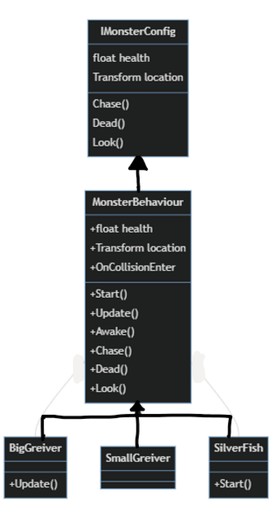i) Polymorphism

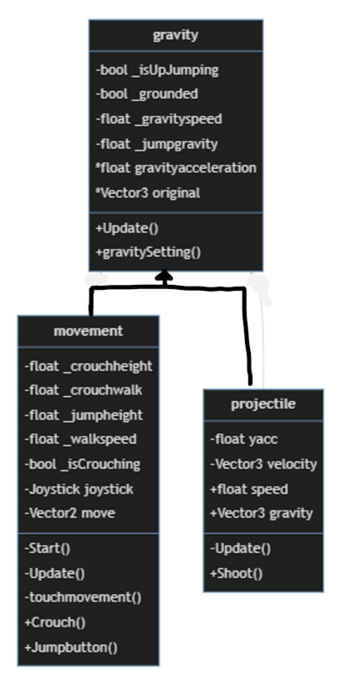

There are sereval monster type in my game. However, they all looks the same except for the speed and alert distance. Inheritance allow me to change some of the code in monsterBehaviour.

This gravity class is the base class for dealing with velocity due to the acceleration of the gravity speed. Both player and weapon needs to be realistic so gravity can provide the y coordinate calculation of gravitational force and projectile motion

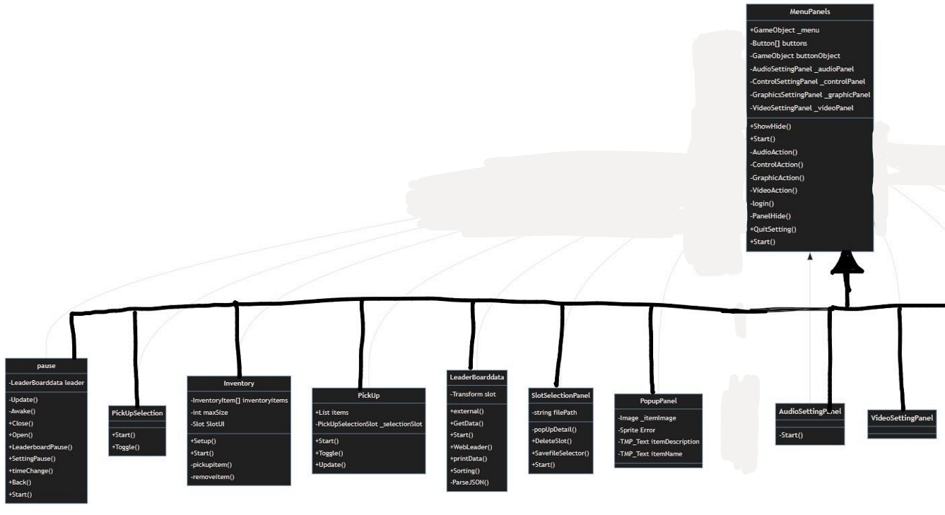 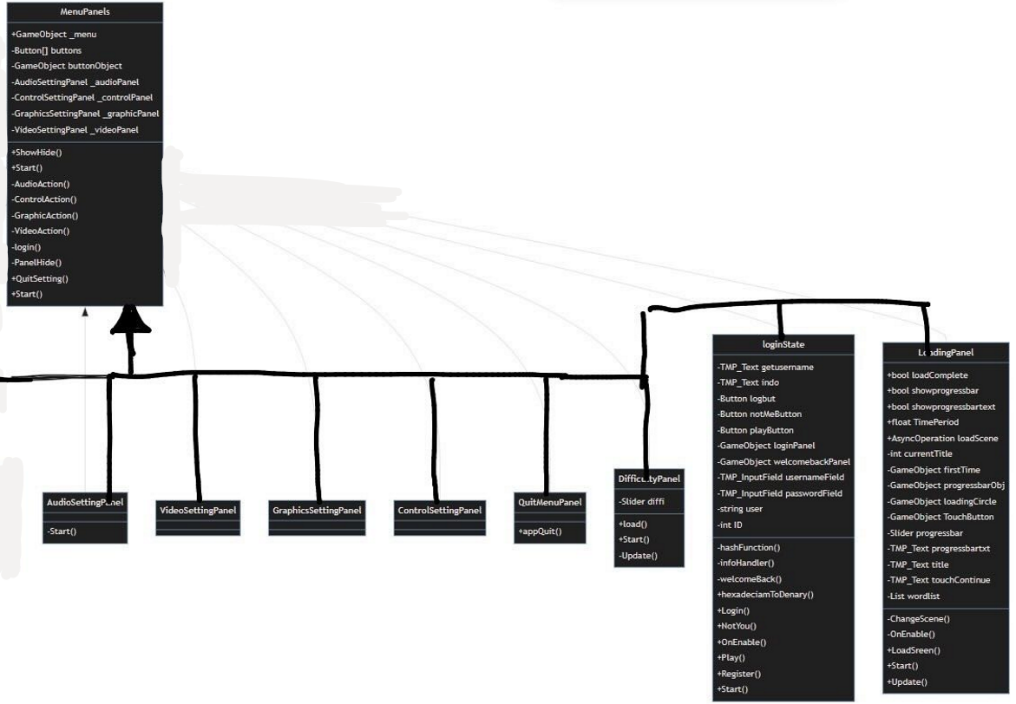



ii) Encapsulation (Aggeration & Composition)

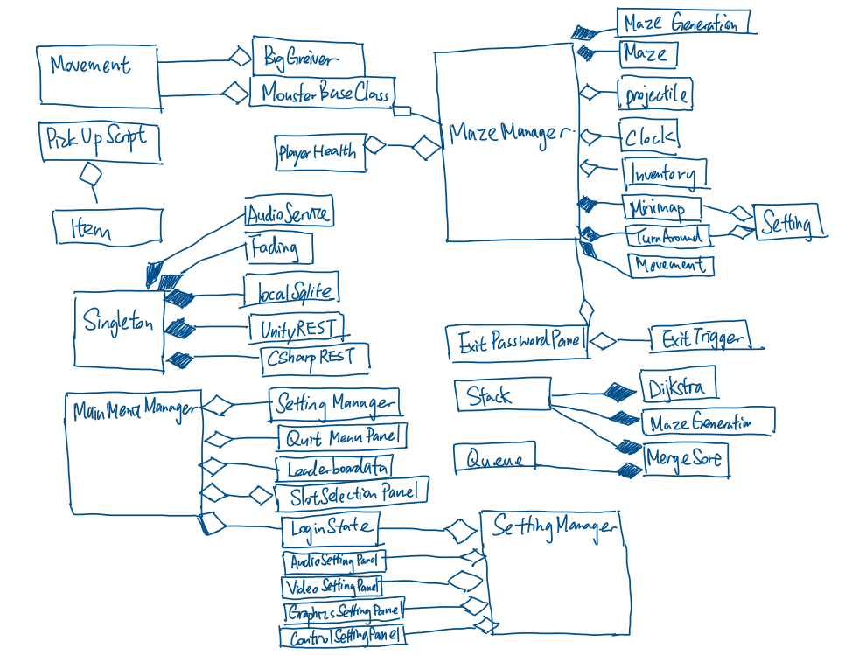

Maze Manager is always enabled and has the most important function to maintain the game working so that maze manager is called by a lot of different class.

## 2.8 Identification of Storage Media

The remote server will be store the data of progress, player info and level details by MariaDB whilst my local database will store the game state and generation of maze, login detail and settings using SQLite.

Reason of choosing local SQLite database because I can minimise the file handling code using SQL declarative programming language. In comparison to online database, it is faster connection and reliable without connecting to the internet.

## 2.9 HCI Rationale

As a realistic 3D mobile game, 3D models is required all around the maze. However, it is not suitable to use low poly model as alternative because it will decrease the realistic of the game. Therefore, It will cost lots of time to creating model all by myself. Luckily, there are lots of unity assets on internet that is free to use. Besides, I want to make the Graphics User Interface of my game looks fancier to attract player so I will use the TMP asset and the User interface template asset. The main colour palette of this game is mostly grey and blue. It represents the maze and the sky as the hope of freedom respectively.

As the game is design in mobile platform, touch friendly is required for the low precision of finger touching. The size of button and font size of text input field could be enlarge and change into a square shape. The colour of button should be bright as most of the texture in the maze and the sky are dark which is hard to see if the button is dark in colour too.

## 2.10 HCI Sample of Planned Input Design

Soundeffect multiplayer NPC appearance object hosse, farming, introduction //storyboard //drawing of the sample game scene

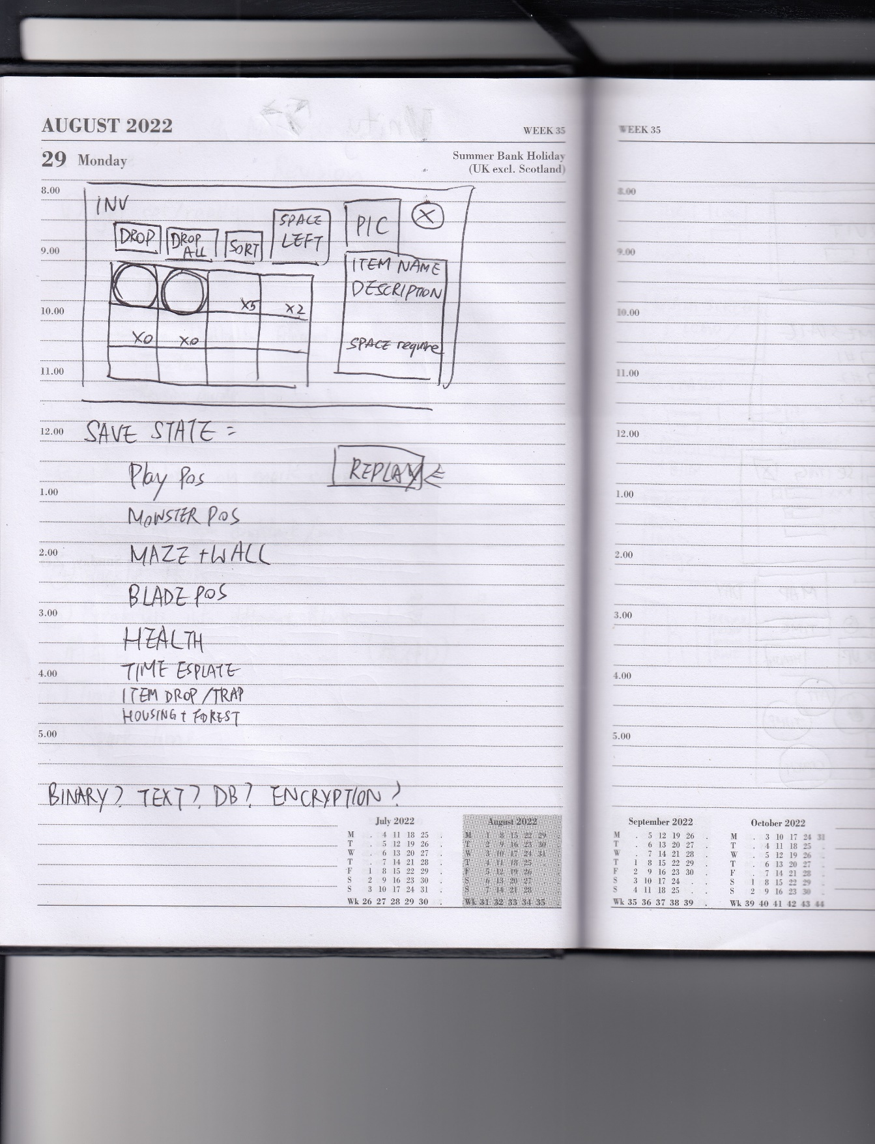 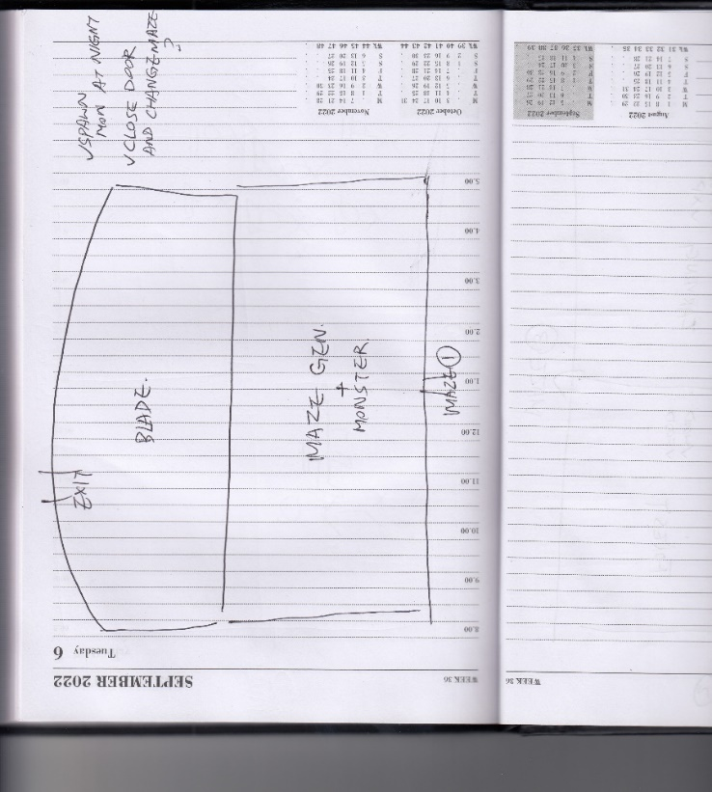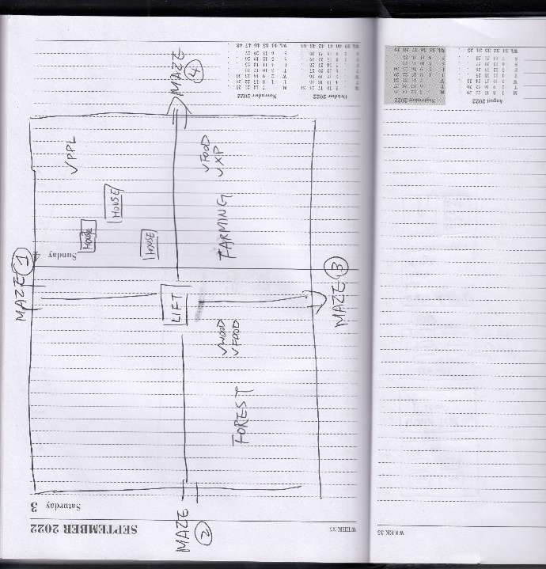 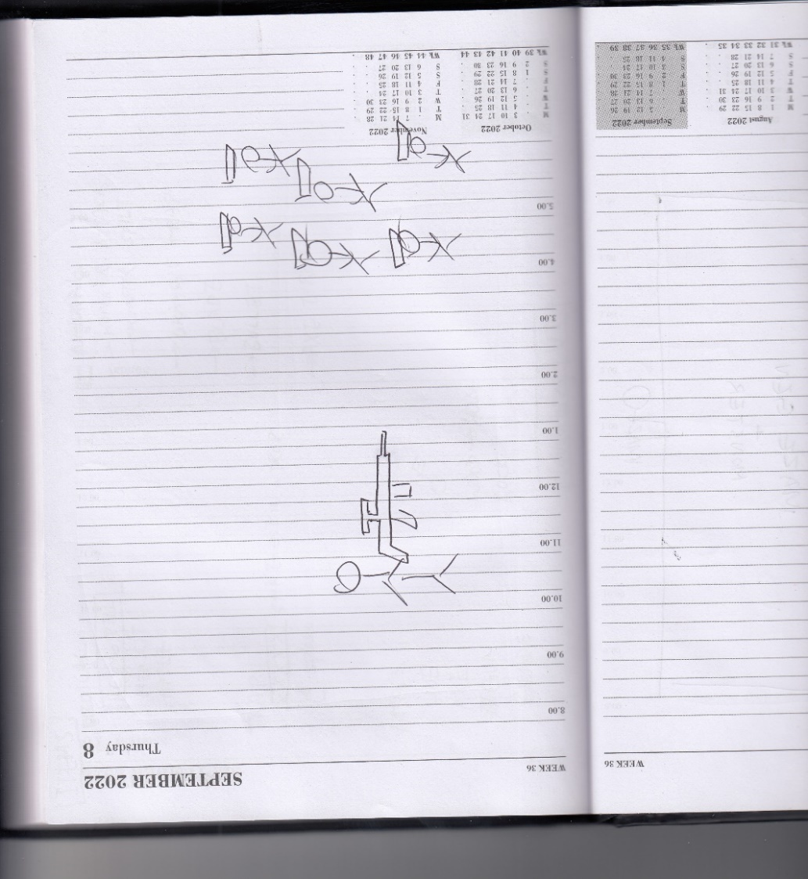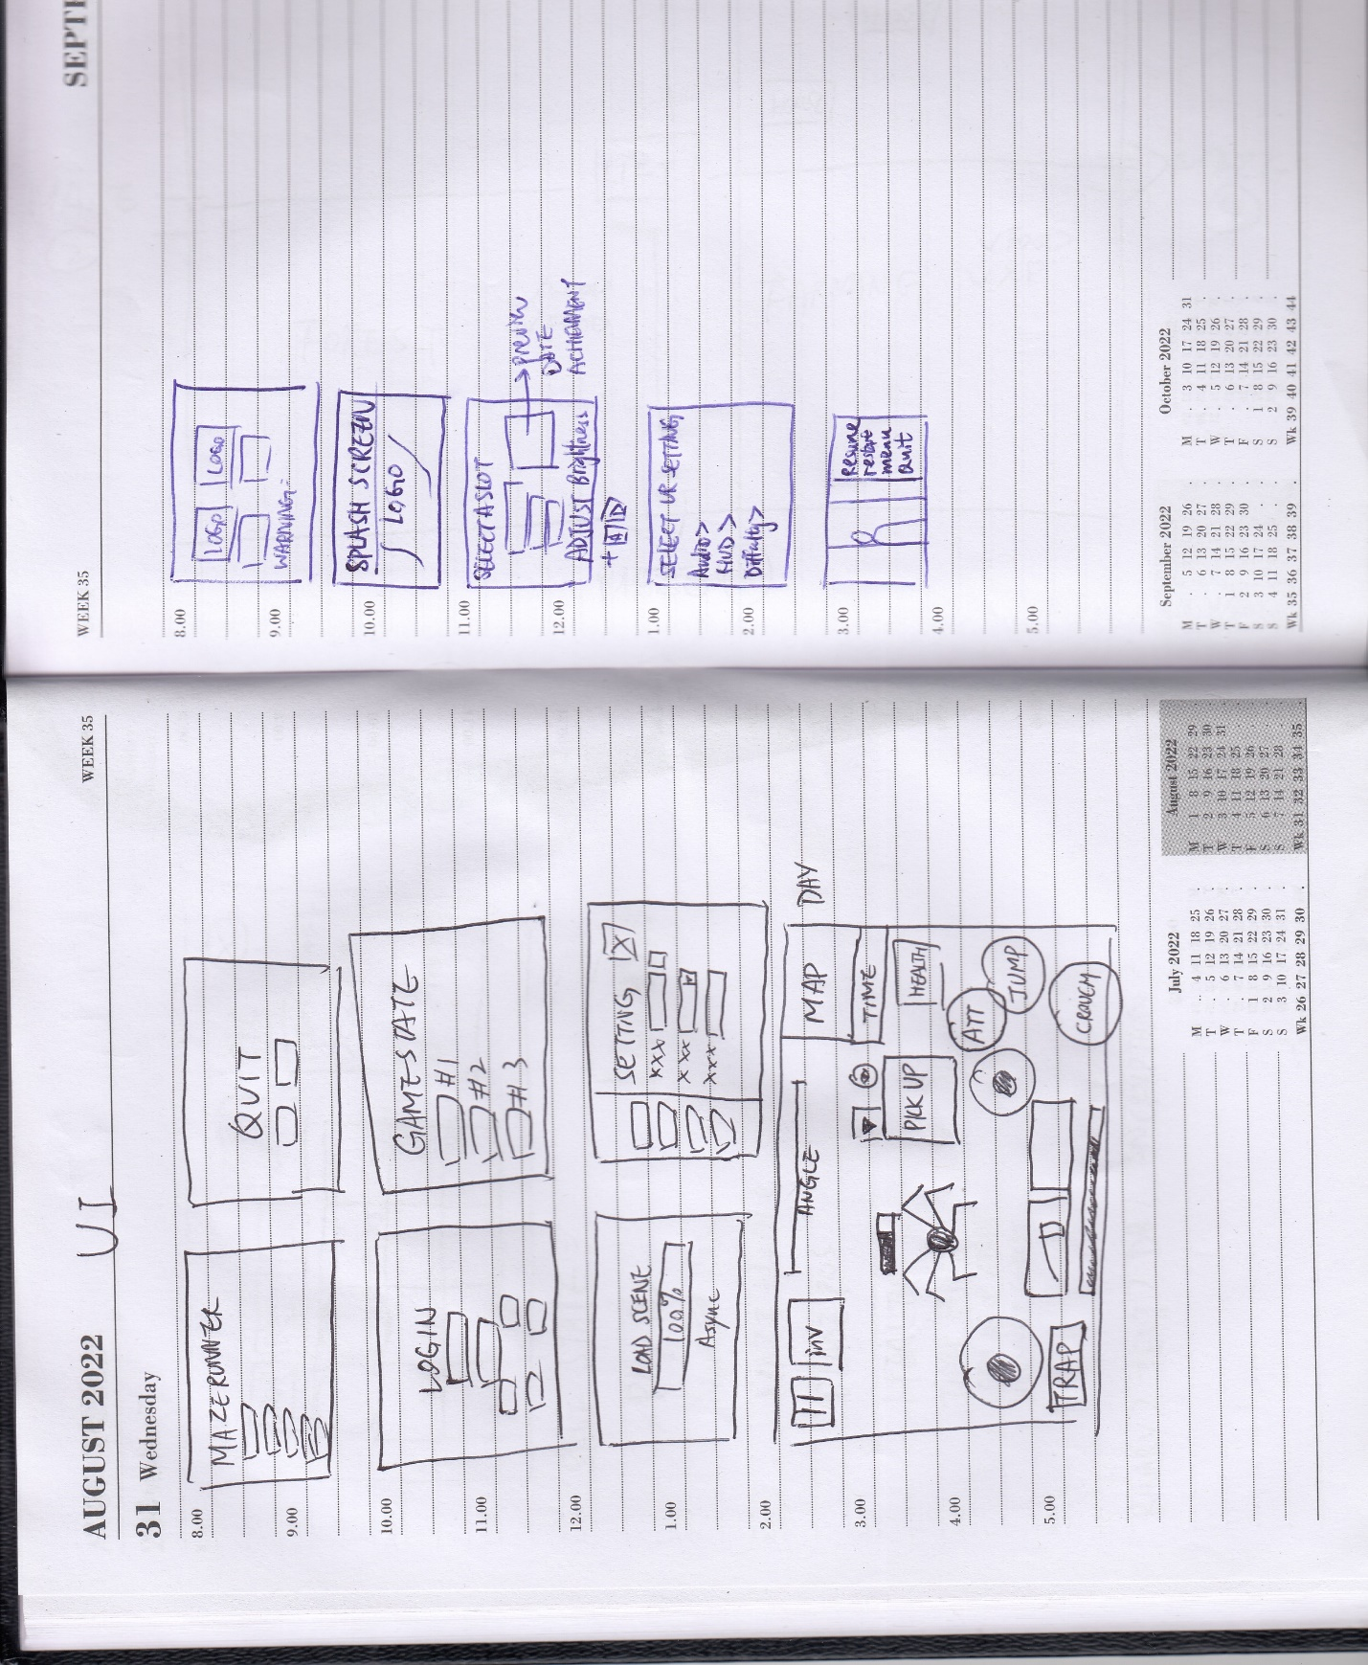 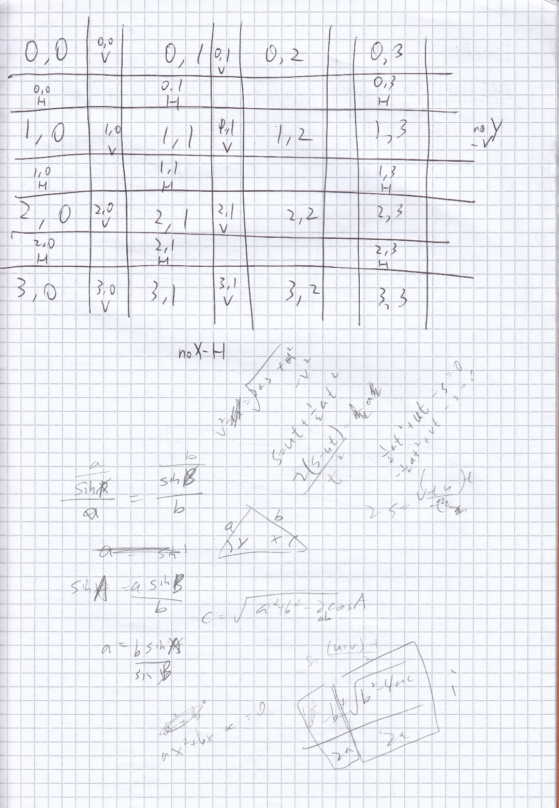



The overview of the maze

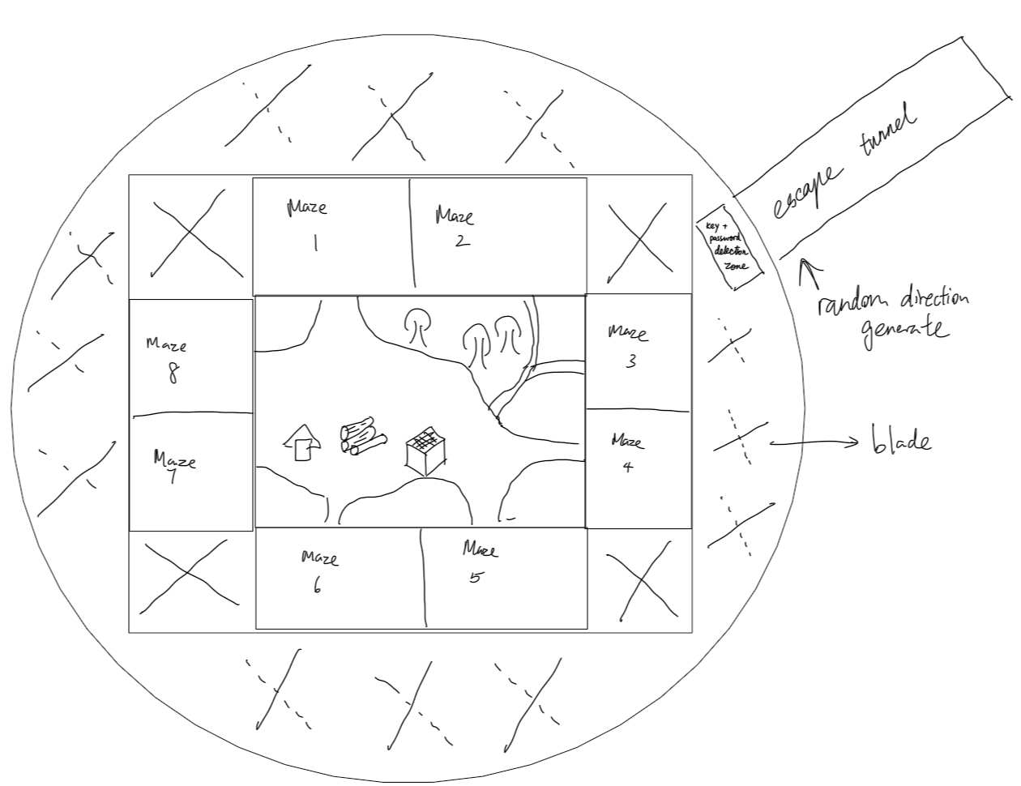

The Storyboard

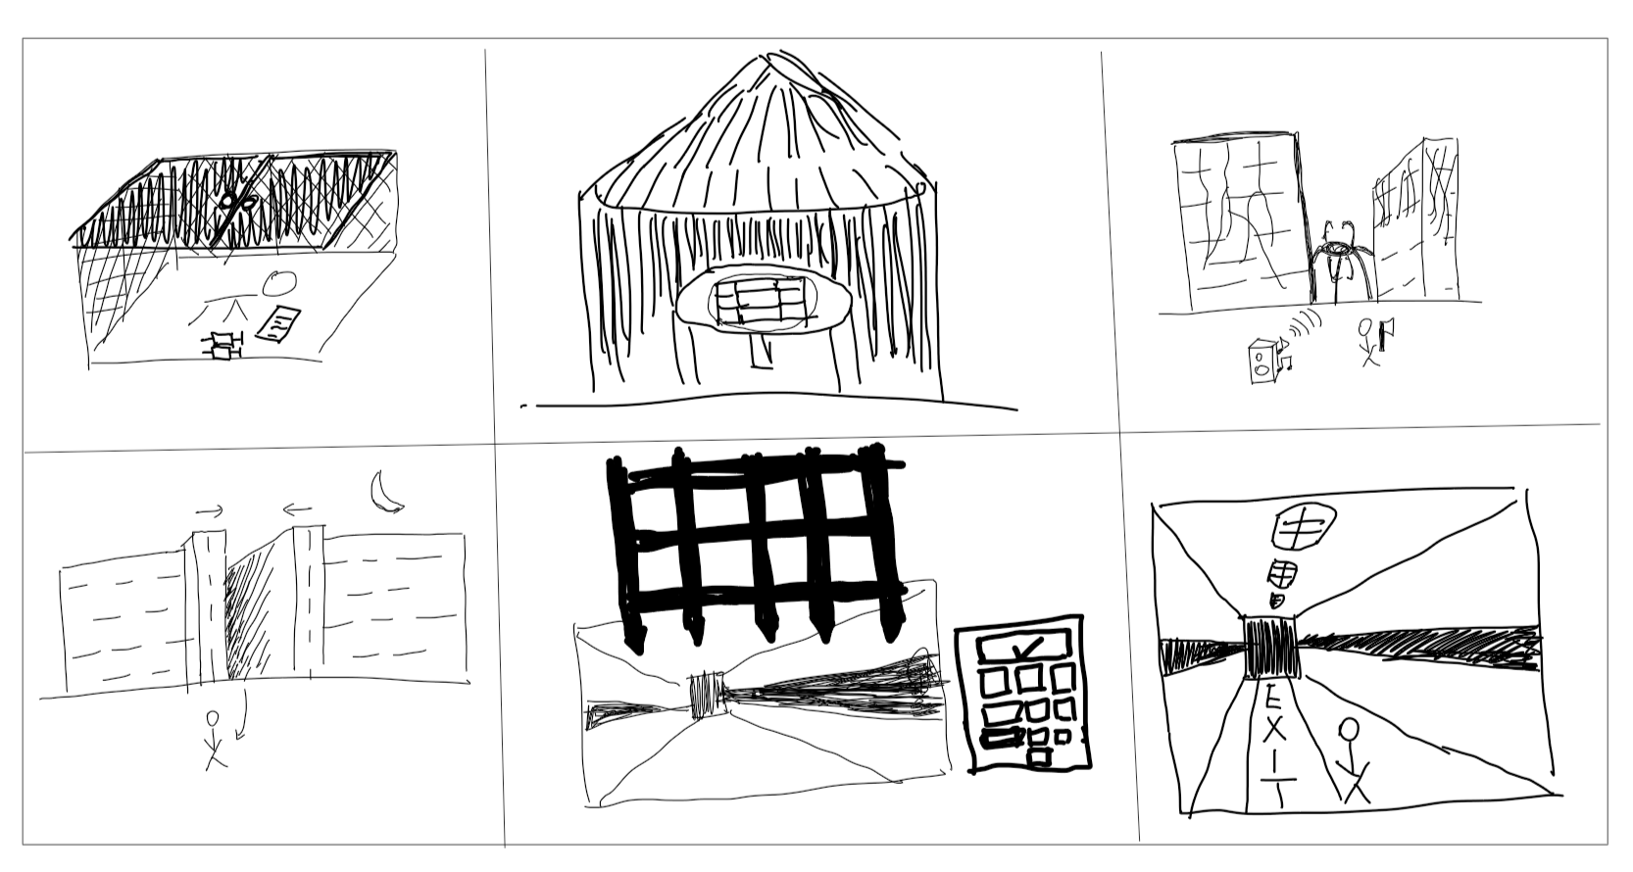

Top Left: The player is sent from the laboratory to the maze by a gauze lift to the maze game

Middle top: the player explore the safe zone in the maze and reveal the map overview of the maze drawn by previous people

Top Right: The player should explore the maze and the Greiver will attract to the sound trap for a while so player can use premade weapon to attack the griever

Bottom Left: At nighttime, the maze gate will closed itself and player must come out of the maze to ensure safety.if player is in between the gate closing, he would suffocate to death

Middle Bottom: the exit gate will be open if the password has been entered correctly

Bottom right: The exit tunnel will be the end of the game

## 2.11 HCI planed output design

The player will

## 2.12 Hardware and Software requirement

A powerful phone which able to run 3D and complex graphics is required as the map of my game is quite large and include a lot of texture. It is essential to have a decent smartphone in order to run this game smoothly. The file size of the game is also quite large due to the texture. Also, register and leader board is out of the game so a browser and network connection is needed

## 2.13 Description of measures planned for security and integrity of data

### 2.13a Security of the data

All the data in the database will be backup into my home server using Rsync protocol. It is based on SSH to provide a encrypted tunnel to backup file to prevent the main database failure. Load balancer has been setup so once the main database is unaccessible, it will automatically redirect to the new database server address.

### 2.13b Integrity of the data

The register website will sanitise the user input and prevent unwanted character. Account will be verified by email One-Time Password to make sure the email address is correct and usable. Password will be stored in a form of hashing and salt data instead of plaintext which can improve the security of user password cracked by hacker

### 2.13c Access Control

A non-admin user is created to access the database with basic privileges including DDL, DML and DQL query only. The password used Upper and lowercase letter, numbers and symbol to form at least 12 digit. The time complexity of cracking the password is O(n!). which is impossible in a lifetime in brute force method.

## 2.14 System security

The server of the server is hosted in a factory in Hong Kong. It is placed in a locked server rack to ensure no one can temper with the physical disk. Although the query is able to access through the internet, both PHP and Node.JS are both backend programming language which normal user has no way to access the code to get the password login, therefore the database is secure from prevent unauthorised access.

Moreover, there is no port forward set in the server. The PHP and Node.JS server scripting only access the LAN to access the data instead of using public IP/ hostname. I have used cloudflare zero trust access platform to setup access right and block out DDoS attack.

There is a risk of being SQL injected by hacker using ‘WHERE user =””’ . To prevent this, all field is sanitised with character checking algorithm and parameterised query is used in PHP and node JS script to prevent SQL injection.

## 2.15 Overall Test Strategy

I am going to use White-box testing for my whole game because the game is developed for mobile platform, which every touch input on the phone is valid. Including the Game Objects that without a listener on touch, the input still count as valid. The test will be based on the objective set in section 1.3 and 1.4 and IPSO table and a narrated testing video will be recorded.

Not only for video testing, but user testing is also a paramount to judge the success criteria of my game. I will ask at least 10 users to test on my game, providing feedback on the game completeness and the improvement could be made.

# 3. Technical Solution

All script is attached into a separate folder which is

|  |  |  |  |
| --- | --- | --- | --- |
| Skills | | | Page |
| >=3 tables interlinked |  | | See 2.4 for E-R diagram | |
| Cross-table SQL |  | | 110 (Section 2.7a TopScore) | |
| Pivot SQL |  | | 110 (Section 2.7a BestScoreOfPlayer) | |
| DDL scripts |  | | 84,88,12,23,27,28,17,85 | |
| DDU script |  | | 110,18,22,23,27,28,30 | |
| Hashing |  | | 5, 77, 110 | |
| Lists | built-in | | 6,7,19,23,24,36,4344,48,49.51,72,73,79,96 | |
| Stacks | Self-made | | 10,44,51-54 | |
| Queues | self-made | | 2,20,24,29 | |
| Trees |  | | 61, 62 | |
| Recursion |  | | 59, 61,62 | |
| Dijkstra algorithm | Self-made | | 94-98 | |
| Merge sort | Self-made | | 7,8,71 | |
| Abstract classes, interface |  | | 58,66 | |
| Classes (simple OOP) |  | | 1- 155 | |
| Inheritance |  | | 11,36,37,38,71,74,79,80,83,85,86,89,91.95,99,9,62, | |
| Interfaces | |  | 108,116 | |
| Server side scripting using request and response objects.(PHP and Node.JS) | |  | 108,109,110,111 | |
| Calling parameterised APIs  Parsing SQL Query Result | |  | 104, 107 | |
| SQLite localdb | |  | 105 | |
| File handling | | Built-in | 16,17 | |
| Multi-dimensional arrays | |  | 6,35,43,48,49,51,52,54 | |
| Binary search | | Self-made | 1 | |
| Text and binary file | |  | 75,76,80 | |

# 4. Testing

## 4.1 Testing method

According to the test strategy I have planned in Section 2.15. I am going to record a video on the game testing. I am going to use the white-box testing as there is no invalid data enter into my system. It is one of the advantage that mobile platform which all input are valid. I am going to use the game objective to test my game as the success criteria of the game. The video will be uploaded onto youtube with timestamp below.

Another testing method would be user testing, I will create a form to ask the player for the feedback and improvement. I will ask for at least 10 player to test my game to make sure the game has been fully tested with different people.

4.2

# 5. Feedback and Evaluation

## 5.1 User Feedback

### 5.1.1 Positive comment I have got is:

“The maze is easy to navigate”

“simple to understand and joystick easy to use”

“The map wasn’t very hard to navigate with difficulty level of 6”

“Pretty cool game especially if you like the game Maze Runner”

“The game is quite straight-forward”

“This game is excellent”

“I liked the mini-map”

“Easy to navigate the maze”

“randomised gate opening was very good”

“The graphics and animation is cool”

### 5.1.2 The negative comment:

“Did see through the wall and lagged a bit”

“The XBOX controller is not human”

“registration in game doesn’t work”

“The wall were difficult to open”

“No introduction to explain how the game works”

“The password of the gate is difficult to understand”

“Not too much Maze Runner content inside the game”

## 5.2 Objective Feedback

### 5.2.1 Bugs that player has encountered is

“login doesn’t work”

“When crouching the game crashed”

“after starting of the game there was a loading screen bug”

“glitches when creating a new account”

“Crashes after game animation”

“Could have a better User Interface ”

“couldn’t exit the login/register page”

“invisible wall has been identified”

“when the game is load, the weapon icon is a white square”

“The animation of the player in 3rd person perspective”

## 5.3 Improvement and extension

### 5.3.1 The improvement comments that player has given is:

“Make the game first person exclusively as the animation is not complete”

“The texture of the maze could be improved”

“Tutorial stage is better to be added in to explain the mechanics and controls”

“Setting Panel could be added in pause screen”

“Monster could be despawn after death/ time based despawn”

“A stamina zbar for character to sprinting and make crouch as default (lower speed)”

“Make a crosshair in the game for aiming”

“Enlarge the player position in the minimap and change the colour to be more visible”

“Make more stage and levels instead of making every maze based on 1 map”

“The opening of the wall could be improved”

“Could be getting a more difficult monsters”

“To have a fully functional login and register so user can see the leaderboard”

“The animation movement could be added to make the game looks more reasonable”

“Make the movement and turning smoother as there is some lag”

“Login pop-up could be disable as it is quite annoying”

“a compass would be useful for locating direction”

“Could have more feature in the maze like housing and farming zone in the maze.”

### 5.3.2 Improvement I could made